 | KINGDOM OF CAMBODIA  Nation Religion King  3  Ministry of Education, Youth and Sport | 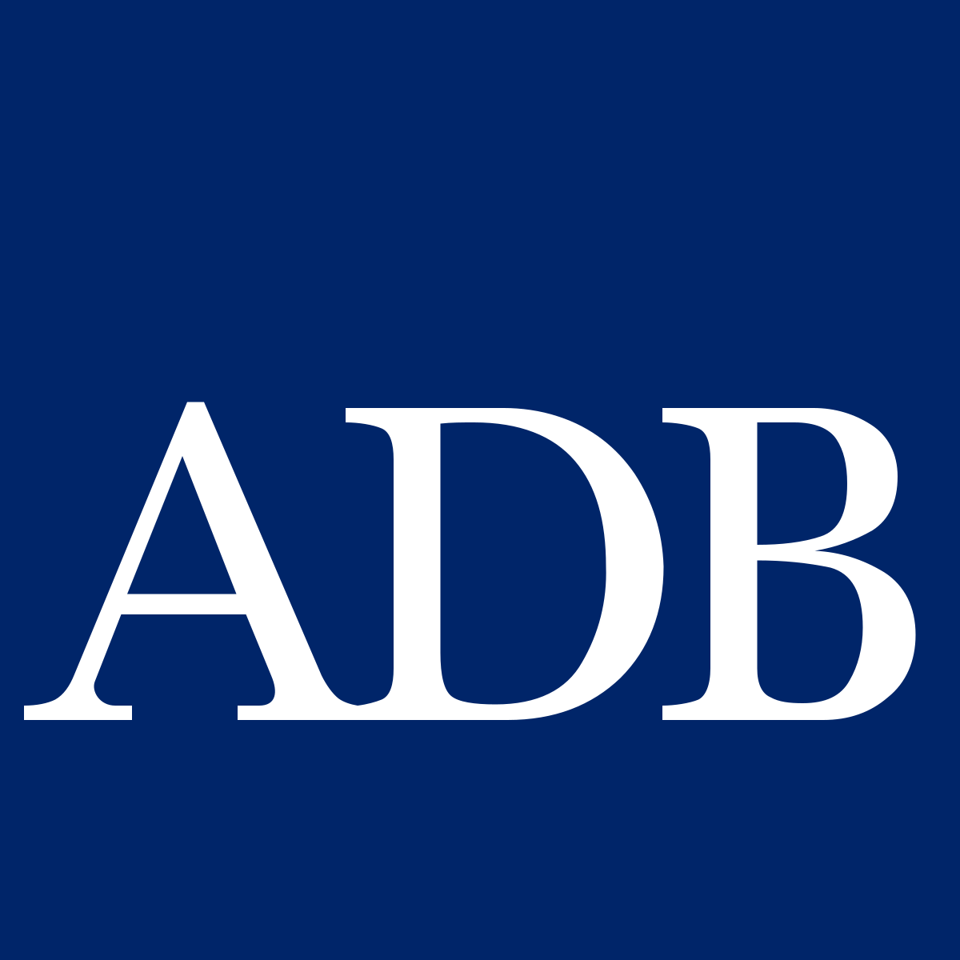

Secondary Education for Human Capital Competitiveness Project (SE4HC)
ADB Loan Nº 4517– CAM (COL)

QUARTERLY PROGRESS REPORT
Q4 2025

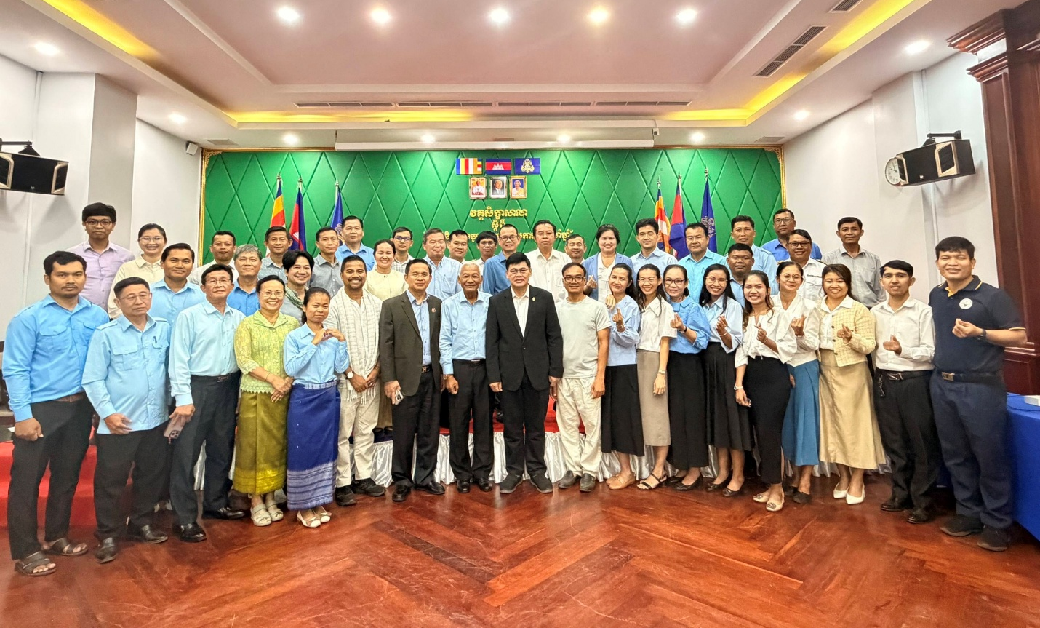

Figure 1: SE4HC Wrap-up workshop presided over by H.E. Dr. Om Romny, Secretary of State of the Ministry of Education Youth and Sport at LBN Asian Hotel, Kampong Cham, 23-25 December 2025

Phnom Penh, 31 December 2025

Abbreviations

ADB | Asian Development Bank
BTEC | Battambang Teacher Education College
CQS | Consultant Qualification Selection
CPD | Continuous Professional Development
CSTC | Cambodia Science and Technology Center
DEA | Department Of Examination Affairs
DGE | Directorate General of Education
DGHE | Directorate General of Higher Education
DOPO | Department Of Policy (MOEYS)
EA | Executing Agency
EDC | Education Data Center
EdTech | Education Technology
EQID | Education Quality Inspective Department (MoEYS)
EMP | Environmental Management Plan
EoI | Express of Interest
GTHS | General Technical High School
HEI | Higher Education Institution
IA | Implementing Agency
IAD | Internal Audit Department
ICS | Individual Consultant Selection
ICT | Information And Communications Technology
IEE | Initial Environmental Examination
IPP | Indigenous Peoples Plan
IT | Information Technology
ITC | Institute Of Technology of Cambodia
LMS | Learning Management System
MEF | Ministry Of Economy and Finance
MOEYS | Ministry Of Education, Youth, And Sports
MSS | Minimum Service Standards
NISE | National Institute for Special Education
NOC | Network Operation Center
NUM-DE | National University of Management Faculty of Digital Economy
OCB | Open Competitive Bidding
PSC | Project Steering Committee
PIC | Project Implementation Consultant
PIU | Project Implementation Unit
PRC | Procurement Review Committee
PTEC | Phnom Penh Teacher Education College
PMU | Project Management Unit
QBS | Quality-Based Selection
QCBS | Quality- And Cost-Based Selection
RFQ | Request For Quotation
RFP | Request for Proposal
RPL | Recognition Of Prior Learning
RTTC | Regional Teacher Training Center
SESS | Special Education Secondary Schools
SMIS | School Management Information System
SOE | Statement Of Expenditures
SRS | Secondary Resource School
STEM | Science, Technology, Engineering and Mathematics
STEP UP | Science And Technology Project in Upper Secondary Education
TEI | Teacher Education Institution
USE | Upper Secondary Education
USS | Upper Secondary School
VFM | Value For Money
VOD | Vocational Orientation Department
WASH | Water, Sanitation and Hygiene

Executive Summary

- Overall Achievement: By 31 December 2025, the project has achieved cumulative physical progress of 6.0% versus elapsed time of 13.00%. The focus during this phase has been on critical preparatory activities including setting up the PMU, PIUs, M&E framework, Gender and Environment and Social Safeguard. As of 31 December 2025, the project is rated as “yellow”. The gender, environment and social safeguards progress, including Indigenous People (IP) continues to be good and on-track. This represents a temporary lag inherent in the initial mobilization period of big projects where start-up activities require more time than physical delivery phrases they precede.
- The total project cost of the SE4HC is US$83.92 million, comprised of US$80 million from ADB and US$3.92 million contribution from the Royal Government of Cambodia (RGC). As of 31 December 2025, the total contract awards were US$ 901,264 (1.13% of the US$80 million) and total disbursement from ADB were US$1,163,900 (1.45% of the US$80 million) (Source: LFIS 31 December 2025).
- Key Implementation Challenges & Corrective Actions
The project’s current low financial utilization and physical performance are the result of several systemic and operational constraints. The Project Management Unit (PMU) has identified these primary challenges and initiated a series of corrective measures to restore momentum as the project transitions into full implementation.
3.1. Technical Expertise and Resource Mobilization
A core challenge is the delay in onboarding the Project Implementation Consultant (PIC) firm. Given that the project introduces sophisticated STEM and digital education methodologies, high-level technical oversight is essential.
- The Constraint: Slow procurement and a scarcity of qualified individual candidates have left key technical positions vacant, hindering the support available to the PMU and PIUs.
- Corrective Action: The Procurement Unit is fast-tracking the finalization of the PIC contract through intensified collaboration with the Ministry of Economy and Finance (MEF). The PIC is scheduled for mobilization in February 2026. Simultaneously, recruitment strategies for individual consultants are being refined—broadening the search to ensure a high-standard technical team is in place to provide the necessary expertise.
3.2. Operational Efficiency and Procurement Optimization
Administrative bottlenecks have historically impacted the project's ability to award contracts and disburse funds on schedule. These stemmed from delayed work plan approvals and fragmented technical communication.
- Synchronized Planning: While the delayed approval of the 2025 Annual Work Plan (AWP) initially hindered progress, the PMU has successfully mitigated this for the current cycle. The 2026 AWP was proactively approved by the MEF in January 2026, enabling all Project Implementation Units (PIUs) to commence activities immediately without a gap in funding or authority.
- Systematized Procurement: To resolve delays caused by vague user specifications and lengthy technical reviews, the PMU has standardized the internal specification-delivery process.
- Real-time Monitoring: A newly launched Procurement Tracking System now provides end-to-end visibility of the approval pipeline. This allows leadership to identify bottlenecks in real-time and coordinate closely with the MEF to prevent disruptions in contract awards and disbursements.
3.3. Institutional Capacity and Leadership
Ensuring that all implementing units operate as a cohesive team is critical for hitting 2026 milestones. Currently, some PIUs face challenges regarding leadership and coordination, which can result in inconsistent outputs.
- Accountability Framework: The PMU is redefining the roles, responsibilities, and Key Performance Indicators (KPIs) for all focal persons. This provides clear expectations for every unit within the project structure.
- Strengthened Coordination: Communication channels have been upgraded, moving from informal updates to mandatory monthly coordination meetings and standardized reporting guidelines. This hands-on management approach ensures that the PMU can provide immediate support where PIUs are struggling.
- Alignment and Team Building: An upcoming Annual Review Workshop will serve as the strategic anchor for the year. This forum will align all stakeholders under a unified implementation strategy, foster a collaborative team spirit, and ensure that all units are working in lockstep toward the project’s overarching goals.

Table of Contents
Abbreviations I
Executive Summary III
1. Introduction and Basic Data 1
1.1. Introduction 1
1.2. Basic Data 1
2. Utilization of Funds 2
2.1. Introduction 2
2.2. Contract Awards 3
2.3. Disbursement 4
3. Project Performance 4
3.1. Status of Project Scope 4
3.2. Assessment of Likelihood of Achieving Project Objectives and Outcomes 5
3.3. Assessment on Changes of Project Scope 5
4. Implementation Progress 5
4.1. Overall Project Progress 5
4.1.1. Output 1: Access to quality upper secondary education expanded. 5
4.1.2. Output 2: Upper secondary education alignment with 21st-century skills improved. 6
4.1.3. Output 3: Quality of upper secondary education learning assessment system improved. 8
4.1.4. Output 4: Post-secondary education pathways strengthened. 9
4.2. Safeguards and Gender: Social, Environmental, Health and Safety, and GAP 10
4.2.1 Safeguards 10
4.2.2 Gender 10
4.3. Financial Management 10
4.3.1. Status of Audit Findings Implementation 10
4.3.2. Project Cost and Expenditures 10
4.3.3. Budget Variance Analysis 11
4.3.4. Financial Projection 12
4.4. Risk Assessment and Risk Management Plan 13
4.5. Compliance with Loan Covenants 20
5. Major Project Issues 21
6. Appendices 22
Appendix 1: Project Implementation Schedule 22
Appendix 2: Detailed Project Implementation Progress 25
Appendix 3: Procurement Plan 27
Appendix 4: Contract Monitoring Form 28
Appendix 5: Procurement Monitoring and Tracking Form (PMTF) 32
Appendix 5.1: Procurement Monitoring and Tracking Form – Goods 32
Appendix 5.2: Procurement Monitoring and Tracking Form – Works 34
Appendix 5.3: Procurement Monitoring and Tracking Form - Consulting Firms 36
Appendix 5.4: Procurement Monitoring and Tracking Form - Individual Consulting 37
Appendix 6: Quarter/Annual Projection Table 41
Appendix 7: Loan Covenants Status 42
Appendix 8: Quarterly Financial Report 52
Appendix 9: Gender Action Plan (GAP) Reporting 54
Appendix 10: Asset and inventory register 2025 61

Tables

Table 1: Basic Data as of 31 Dec 2025 1
Table 2: Summary of Loan Utilization as of Q4 2025 2
Table 3: Summary of RGC Fund Utilization as of Q4 2025 3
Table 4: Summary of Contract Awards by Category 3
Table 5: List of Contracts Awards as of Q4 2025 3
Table 6: Expenditure by Category 11
Table 7: Expenditures by Outputs 11
Table 8: Expenditure of Current Quarter 12
Table 9: Annual Projection for 2025 12
Table 10: Projection Table for 2025 by Quarter 12
Table 11: Key implementation issues and planned mitigation 21

Introduction and Basic Data

1.1. Introduction

- The Secondary Education for Human Capital Competitiveness Project (SE4HC) will support priorities of phase 2 of Cambodia's Secondary Education Blue-print (CAMSEB) 2030. The project's impact is aligned with the government’s Pentagonal Strategy and CAMSEB which highlight the importance of high-quality human resources to develop a knowledge-based society. The outcome will be effectiveness of a gender-inclusive upper secondary education system improved.
- SE4HC Project supports Cambodian secondary students nationwide in their pursuits to learn and develop relevant skills that will enable them to support themselves, their communities and the economy. SE4HC aims to strengthen the education system by making it more inclusive and addressing bottlenecks that hinder interactive teaching and learning. This project is part of the Asian Development Bank (ADB)’s sequenced support as a longstanding partner in the upper secondary education (USE) subsector in Cambodia. To improve effectiveness of a gender-inclusive upper secondary education system, the project will focus on (i) expanding access to quality USE, (ii) improving USE alignment with 21st-century skills, (iii) improving the quality of USE learning assessment, and (iv) strengthening post-secondary education pathways.
- The SE4HC is a 6.5-year-project commencing December 2024 and closing on 30 June 2031. The Ministry of Education, Youth and Sport (MoEYS) will serve as the executing agency to be fully responsible for carrying out the project under the established guidelines and procedures and will assign individuals and teams from within its existing structure to be responsible for project implementation. Institute of Technology of Cambodia (ITC) is the Implementing Agency. Directorate General of Education (DGE), and Directorate General of Higher Education (DGHE) are the Project Implementation Units (PIUs) established by the executing agency and are under the Project Management Unit (PMU).
- The project is estimated to cost $83.92 million, to be financed with concessional loan of $80.00 million from ADB and the government counterpart financing of $3.92 million.
- This Q4 2025 report reports on the progress and achievements of the project covering from 01 October to 31 December 2025.

1.2. Basic Data

Table 1: Basic Data as of 31 Dec 2025
Loan Number: | ADB Loan No. 4517– CAM (COL)
Project Name | Secondary Education for Human Capital Competitiveness Project (SE4HC)
Sector/Sub-Sector | Education sector, upper secondary school sub-sector
Executing Agency (EA) | Ministry of Education, Youth and Sport (MoEYS) of the Royal Government of Cambodia (RGC)
Implementing Agency (IA) | Institute of Technology of Cambodia (ITC)
Project Implementation Unit (PIU) | Directorate General of Education (DGE), and  Directorate General of Higher Education (DGHE)
Total Project Cost (US$ million) | Total: US$ 83.92 million (ADB: US$ 80.00 million RGC: US$ 3.92 million)
Financing Source(s) | Financiers | Amount (US$ million) | Share of Total (%)
Financing Source(s) | ADB | US$80 million | 95.33%
Financing Source(s) | RGC | US$3.92 million | 4.67%
Date of Project Approval | 30 October 2024
Date of Signing of Loan Agreements | 17 December 2024
Date of Loan Effectiveness | 06 March 2025
Closing Date of Loan | 30 June 2031
Revised closing date (if applicable) | n/a
Dates of Last Review Mission | 31 March – 8 April 2025
Project Impact | High-Quality Human Resources for Knowledge-based Society developed.
Project Outcome | Effectiveness of a gender-inclusive upper secondary education system improved.
Project Outputs | Output 1: Access to quality upper secondary education expanded  Output 2: Upper secondary education alignment with 21st-century skills improved  Output 3: Quality of upper secondary education learning assessment system improved  Output 4: Post-secondary education pathways strengthened
Allocation of Loan Proceeds | Components/ items | Amount (US$) | Share of Total (%)
Allocation of Loan Proceeds | Works | 28,776,046 | 35.97%
Allocation of Loan Proceeds | Goods | 21,549,138 | 26.94%
Allocation of Loan Proceeds | Consulting Services | 8,396,300 | 10.50%
Allocation of Loan Proceeds | Capacity development | 8,885,937 | 11.11%
Allocation of Loan Proceeds | Recurrent cost | 2,769,515 | 3.46%
Allocation of Loan Proceeds | Unallocated | 9,767,064 | 12.03%
Allocation of Loan Proceeds | Total | 80,000,000 | 100.00%
Project Area | 259 High Schools: 57 Secondary Resource Schools (SRS), 05 General and Technical High School (GTHS), 86 Network SRSs, and 111 General Education High Schools (GEHS) in 25 provinces/municipalities.
Overall Project Progress (as of this report) | 6.0% of the physical progress as of this report
Elapsed time | 13.00% from the loan effective date

2. Utilization of Funds

2.1. Introduction
- The total project cost of the Secondary Education for Human Capital Competitiveness Project (SE4HC) is US$ 83.92 million, which comprises of US$ 80.00 million from ADB and US$3.92 million contribution from the Government of Kingdom of Cambodia (GKC). Below is summary table for the use of funds:
Table 2: Summary of Loan Utilization as of Q4 2025
Ref. | Category Name | Amount (in US$)
Ref. | Category Name | Current Allocation | Contracts Awarded | Uncontracted Balance | [Contracts] Disbursed | Undisbursed Balance
Ref. | Category Name | A | B | C = A-B | D | E = A-D
1 | Civil works | 28,776,046 |  | 28,776,046 |  | 28,776,046
2 | Goods | 21,549,138 | 163,900 | 21,385,238 | 163,900 | 21,385,238
3 | Consulting services | 8,396,300 | 737,364 | 7,658,936 |  | 8,396,300
4 | Capacity building | 8,885,937 |  | 8,885,937 |  | 8,885,937
5 | Recurrent cost | 2,769,515 |  | 2,769,515 |  | 2,769,515
6 | Unallocated | 9,623,064 |  | 9,623,064 |  | 9,623,064
7 | Advance account |  |  |  | 1,000,000 | (1,000,000)
 | Total: | 80,000,000 | 901,264 | 79,098,736 | 1,163,900 | 78,836,100
Source: LFIS

Table 3: Summary of RGC Fund Utilization as of Q4 2025
Ref. | Category Name | Amount (in US$)
Ref. | Category Name | Current Allocation | Contracts Awarded | Uncontracted Balance | [Contracts] Disbursed | Undisbursed Balance
Ref. | Category Name | A | B | C = A-B | D | E = A-D
1 | Capacity Building | 300,451 | - | 300,451 |  | 300,451
2 | Recurrent cost | 809,400 |  | 809,400 |  | 809,400
3 | Interest Charge | 2,656,130 |  | 2,656,130 | 2,889 | 2,653,241
4 | Unallocated | 154,019 |  | 154,019 |  | 154,019
 | Total: | 3,920,000 | - | 3,920,000 | 2,889 | 3,917,111
Source: Financial unit

2.2. Contract Awards
- 10. By Q4 2025, Cumulative contract award is US$ 901,264. Table 4 shows contract awards within each category (civil works, goods and consulting services) awarded by Q4 2025.
Table 4: Summary of Contract Awards by Category
Cat. Ref. | Category Name | Contracts Awarded (US$)
1 | Civil works | -
2 | Goods | 163,900
3 | Consulting services | 737,364
 | Total: | 901,264
Source: Financial unit

- By Q4 2025, there are 13 contracts have been awarded. Table 5 shows the contracts awarded in Q4 2025.
Table 5: List of Contracts Awards as of Q4 2025
PIU/IA | Component/ Output | Package Number | Type of Contract | General Description | Contract  Amount (US$) | Status
PMU | Project Management | ICS-8A | ICS | National Procurement Consultant for Goods and Works | 143,719 | Contract Signed, Mr. Rath Sophak
PMU | Project Management | ICS-8B | ICS | National Procurement Consultant for consulting Services | 143,719 | Contract Signed, Mr. Doung Makara
PMU | Project Management | ICS-9B | ICS | National Financial Management Specialist | 149,647 | Contract Signed, Mr. Khiev Chandara
PIU2 | Output 4 | ICS-5A | ICS | International Specialized Courses for Grades 11 and 12 Specialist for (Design and Implement – Digital Economy and Applied Math) | 106,088 | Contract awarded, Dr. Mayra Christina
PIU2 | Output 4 | ICS-5B | ICS | National Specialized Courses for Grades 11 and 12 Specialist  (Design and Implement – Digital Economy and Applied Math) | 22,000 | Contract awarded, Mr. Kuch Savath
PIU2 | Output 4 | ICS-6A | ICS | International Fast Track Learning Management Specialist  For the National University of Management (NUM) | 34,123 | Contract awarded, Dr. Kimji Vaghjiani
PIU2 | Output 4 | ICS-6B | ICS | National Fast Track Learning Management Specialist  For the National University of Management (NUM) | 5,952.94 | Contract awarded, Mr. So Sovichea
PIU2 | Output 4 | ICS-7A | ICS | International Curriculum Review Specialist for the National University of Management (NUM), Faculty of Digital Economy (Subject: Digital Economy) | 35,813.95 | Contract awarded, Prof. Ilkwon Chae
PIU2 | Output 4 | ICS-7B | ICS | International Curriculum Review Specialist for the National University of Management (NUM), Faculty of Digital Economy (Subject: Financial Technology) | 25,472 | Contract awarded, Prof. Langnan Chen
PIU2 | Output 4 | ICS-7C | ICS | International Curriculum Review Specialist for the National University of Management (NUM) Digital Economy Program  (Subject: Smart City Planning and Management) | 35,860 | Contract awarded, Mr. Daniel Oscar
PIU2 | Output 4 | ICS-7D | ICS | International Curriculum Review Specialist  for the National University of Management (NUM), Faculty of Digital Economy (Subject: computer Science) | 27,981.4 | Contract awarded, Dr. Mayra Christina
PIU1 | Output 1 | ICS-10 | ICS | National Gender Strategic Implementation Plan Specialist | 6,988.08 | Contract awarded, Mr. Hong Sochea
PMU | Project Management | GD-23 | Goods | Purchase of 4 Vehicles for the Project | 163,900.00 | Contract with HB Auto Co., Ltd
Source: Procurement Unit

2.3. Disbursement

- The SE4HC Project has received initial advance from ADB US$ 1 million.
The below table shows the details of project expenditures during the quarter/year-to-date/cumulative-to-date.
Category Expenditure | This Quarter |  |  | Year to Date |  |  | Cumulative to Date
Category Expenditure | Loan | RGC | Total | Loan | RGC | Total | Loan | RGC | Total
Civil works | - | - | - | - |  | - | - | - | -
Goods | 163,900 |  | 163,900 | 163,900 |  | 163,900 | 163,900 |  | 163,900
Consulting services | 38,747 |  | 38,747 | 50,175 |  | 50,175 | 50,175 |  | 50,175
Capacity Development | 19,146 |  | 19,146 | 19,146 |  | 19,146 | 19,146 |  | 19,146
Recurrent cost | 187,278 |  | 187,278 | 270,380 |  | 270,380 | 270,380 |  | 270,380
Interest Charge | - | 2,889 | 2,889 | - | 2,889 | 2,889 | - | 2,889 | 2,889
Unallocated
Total | 409,071 | 2,889 | 411,960 | 503,600 | 2,889 | 506,489 | 503,600 | 2,889 | 506,489

3. Project Performance

3.1. Status of Project Scope
- The overall project scope is to improve the effectiveness and gender inclusivity of the upper secondary education system in Cambodia especially in the area of STEM and digital technology in upper secondary education, through the piloting interventions in 259 upper secondary target schools including 50 SRSs. In order to support the MoEYS in implementing the project and monitoring the achievement of the project outcomes and outputs ADB confirmed no objection on 12 June 2025 in regard to the proposed project administration manual (PAM).
- Based on the PAM, the project implementation period will commence from the loan signing date, currently scheduled in 17 December 2024 and the project is effective on 06 March 2025.

3.2. Assessment of Likelihood of Achieving Project Objectives and Outcomes
- By 31 December 2025, ADB has issued a No Objection Letter dated 12 June 2025 to the annual workplan and budget 2025 with a total estimated amount of $1,376,000 ($1,289,800 from ADB loan and $89,100 from the RGC counterpart financing). Based on the Annual Workplan Budget 2025cover on the output 1, output 2, output 4 and PMU with the activities centered on planning and pre-assessment. Meanwhile, the activities are implemented only in Q3 and Q4 of 2025.

3.3. Assessment on Changes of Project Scope
- After the official launching ceremony on 01 April, 205 at Institute of Technology of Cambodia, the project has not yet changed the scope.

4. Implementation Progress

4.1. Overall Project Progress
- By 31 December 2025, the project progress is relatively low compared to the original plan, with cumulative physical progress at 6.0% versus elapsed time of 13.00%. As of 31 December 2025, the project is rated as “yellow”. The gender, environment and social safeguards progress, including Indigenous People (IP) continues to be good and on-track.
- The total project cost of the SE4HC is US$83.92 million, comprised of US$80 million from ADB and US$3.92 million contribution from the Royal Government of Cambodia (RGC). As of 31 December 2025, the total contract awards were US$ 901,264 (1.13% of the US$80 million) and total disbursement from ADB were US$1,163,900 (1.45% of the US$80 million) (Source: LFIS 31 December 2025).

4.1.1. Output 1: Access to quality upper secondary education expanded.
- Overview: This output will increase students’ access to well-equipped, safe, climate-resilient upper secondary school (USS) facilities. Implementation of Output 1 will be led by project implementation unit (PIU)1 - Directorate General of Education (DGE) in coordination with Department of General Secondary Education (DGSE), Vocational Orientation Department (VOD), Department of Monitoring and Evaluation, the Department of Special Education and the National Institute for Special Education (NISE). The implementing agency (IA) Institute of Technology of Cambodia (ITC) will be responsible for establishment and operation of the Education Data Center (EDC).
- The output 1 focusses on (i) Construction and furnishing of additional 414 classrooms and water, sanitation, and hygiene (WASH) facilities (including 300 toilets) in 23 crowded schools. (ii) Upgrading and equipping of existing USS facilities to promote applied science and extra-curricular teaching and learning. (iii) Development of MOEYS guidelines for climate-resilient school facilities. (iv) Review and update of minimum service standards (MSS) for general technical high schools (GTHS). (v) Establishment and equipping of an integrated education data center. (vi) Development of the new MOEYS Gender Mainstreaming Strategic Plan 2026- 2030. (vii) Support for inclusive education.
- This section describes the detailed activities of each of the sub outputs of output 1 including (i) challenges and (ii) impact.
- Sub-output 1.1: Construction and furnishing of additional 414 classrooms and water, sanitation, and hygiene (WASH) facilities (including 300 toilets) in 23 crowded schools. The MOEYS’ Department of State Property and Construction (DSPC) has completed site assessments on the construction 23 school building. The site assessments of the classroom renovation for 245 schools have been completed 100% including – (1) Conversion of existing classrooms to science labs and provision of related furniture and equipment in 102 schools (100%); (2) Conversion of an existing classroom to a computer lab and provision of related furniture and equipment in 111 schools (100%). (3) Conversion of an existing classroom to a multipurposed room in 72 schools (100%). (4) Conversion of two existing classrooms to smart classrooms in 110 schools (100%). (5) Conversion of a classroom to a library in 38 schools (100%). (6) Conversion of an existing classroom to a teachers’ room in 98 schools (100%). The site assessments of Installation of solar panels with batteries in 90 schools have been completed (100%). The site assessments of Installation of Intranet in 128 schools have been completed (100%).
- Sub-output 1.2: Upgrading of and equipping existing USS facilities to promote applied science and extra-curricular teaching and learning. The consultative workshop to prepare a List of experimental Materials for target High Schools has been prepared in Kampong Chhnang Province with the total number of 60 participants (Female 15). The list of equipment and materials were prepared for informing the procurement process.
- Sub-output 1.3: Development of MOEYS guidelines for climate-resilient school facilities. Evaluation of an international and one national specialist to support MOEYS in development guidelines for climate-resilient school facilities is completed. These two specialists are selected, and the contract negotiation are in progress. The contract award is expected by January 2026.
- Sub-output 1.4: Review and update of minimum service standards (MSS) for general technical high schools (GTHS). Minimal progress has been made under this activity to date. A review of the MOEYS standards for GTHS has commenced and will be ready for further input from the international MSS specialist, who will have only one person-month input. The concept note for implementing this activity has been prepared. The standards will be designed specifically for GHTS.
- Sub-output 1.5: Establishment and equipping of an integrated education data center. Following the EoI selection process, the first shortlisted firm has been requested to submit its technical proposal.
- Sub-output 1.6: Development of the new MOEYS Gender Mainstreaming Action Plan 2026- 2030. During the ADB Inception Mission (31 March – 08 April 2025), it was clarified that the preparation of the GMSP 2024–2028 is already being financed by UNICEF through the Global Partnership for Education (GPE) and the Capacity Development Partnership Fund (CDPF). Given this overlap, PMU requested that the SE4HC budget originally allocated for Activity 1.6 be reprogrammed to support the Development of the GMSP Action Plan, which will be initiated after the Strategic Plan is formally adopted. The consultant is selected and the contract has signed on 9 December 2025 with Mr. Hong Sophea. Inception report with a detail plan for the development of the GMSP Action Plan was produced.
- Sub-output 1.7: Support for inclusive education. A consulting firm is being procured to develop Khmer text-to-speech software/application and Braille translation software for special education. The TOR have been prepared, with advertisement planned for January 2026. A committee has been established to select scholarship recipients from among NISE staff and special education teachers.

4.1.2. Output 2: Upper secondary education alignment with 21st-century skills improved.
- Overview: This output aims to increase in-demand skills in USE students through (i) improving teacher competency and pedagogy in priority areas of English language, STEM, and digital skills; and (ii) attracting students to the science stream, a strategic priority for the Cambodian economy. Skills of leadership, entrepreneurship, communication, goal setting, innovation, problem-solving, and collaboration (also referred to as 21st century skills) will be enhanced through increasing the use of project-based teaching and learning.
- Implementation of output 2 will be led by PIU1 - DGE in coordination with ITC and National Institute of Education (NIE), Battambang Teacher Education College (BTEC), Phnom Penh Teacher Education College (PTEC), Regional Teacher Training Center (RTTC) in Kampong Cham province, and the Directorate General for Teacher Education.
- Sub-output 2.1: Provision of CPD to secondary school teachers on soft skills and project-based STEM education. The following activities has been conducted:
- (1) Conducted study visit (ITC and NIE team) to relevant high schools to collect inputs on CPD training program towards Project-Based Learning. The on-site survey as need analysis by conduct school visits, STEM teachers survey, and Input from relevant institutions/people has conducted 2-time study visits to schools at Kandal, Kampong Chhnang, Kampong Speu, Prey Veng, and Svay Rieng Provinces (Tep Bronom, Udong, Boribo Thbong, Svay Reang, Ang Dung, and Kampong Porpil High schools). The next 2 trips will be in December 2025 at Kampong Cham, Kampong Thom, Battambang, and Siem Reap Provinces. The working groups are from ITC and NIE. The key results included – (a) Teachers are motivated but lack skills in PBL design, STEM integration, and project assessment. Then, CPD must focus on practical PBL methodology. (b) Low laboratory and technical capacity (equipment use, safety, experiment setup). Then, CPD should include hands-on lab and technical training. (c) Insufficient materials and consumables for PBL implementation. Then, CPD must teach low-cost STEM tools and project preparation. (d) No dedicated PBL time or workspace in many schools. Then, CPD should guide schools on organizing schedules and creating innovation spaces. (e) High-demand PBL themes include water purification, composting, renewable energy, recycling, robotics, and food science. Then, CPD modules should align with these topics. (f) Need for continuous mentoring from ITC/NIE. Then, CPD should include follow-up support and shared digital resources.
- (2) Conducted workshop to finalize the CPD training materials to secondary school teachers in context of Project-Based Learning on 27-29 November 2025 at LBN Hotel in Kampong Cham Province with 40 participants (Female 12). The workshop has agreed to simplify theory and make the CPD materials more practical and hands-on; emphasized multidisciplinary STEM projects with entrepreneurship and real-life application; strengthened assessment components, including project proposals, project outcomes, and student self-assessment; confirmed training structure of 5 days + 3 days with a focus on practice, coaching, and follow-up; and provided clear direction for refining Modules 1–3 to better support teachers and students in STEM project-based learning. ITC will complete the final CPD curriculum and training materials and consult with relevant high schools before conducting ToT training in the next quarter.
- Sub-output 2.2: Applied STEM and innovative learning fund. Project schools will receive funds for (i) teachers to continue the project-based STEM CPD program back in their schools; (ii) teachers to provide remedial classes; and (iii) the implementation of a student peer support system or study clubs. These activities will start in Q1 2027 as the last phase of the CPD training.
- Sub-output 2.3: Upgrading of USE science and math subject teachers’ qualifications. Merit and needs-based scholarships will be provided to 250 science and math subject team leads (25% women) from USSs who have successfully completed the CPD program to pursue local master’s degree programs in science and math teaching. As the CPD program has not yet commenced, this activity will begin upon completion of the CPD program.
- Sub-output 2.4: Provision of CPD to USE teachers on digital skills. This pilot CPD will leverage regional teacher education institutions (TEIs) in Battambang and Kampong Cham, and Phnom Penh, which have previously focused on trainings for primary and LSE levels. The project will also strengthen capacity of TEIs, which is aligned with MOEYS’ plan in expanding roles of regional-based TEIs to support schools in an effective and cost-efficient way.
- (1) Conducted Study Visit (PTEC, BTEC, RTTC-KC) to relevant high schools to collect input on CPD training program on digital integration in teaching and learning. In November 2025, the working group has visited 2 provinces. Kampong Chhnang Province includes – Preah Bat Samdech Preah Baramneath Norodom Sihamoni GTHS, Techo Teuk Huot HS, Hun Sen RoleaBa’ear HS. Koh Kong Province include – Koh Kong HS, Botumsako HS, and Srae Ambel HS. (2) conducted the study visit in Stung Treng Province which includes – Royal Crusade HS, Hun Sen Koh Srolay HS and Borey O’Svay Senchey HS. The working group are from BTEC, PTEC, RTTC-KC, DSGE, DDT (organized by BTEC).
- (3) Conducted technical workshop (BTEC, PTEC, RTTC-KC) to conceptualize the CPD program on digital integration in teaching and learning for secondary schools. The specifications for ICT equipment and smart classrooms have been prepared, and advertisement is expected in early Q1 2026.
- (4) The proposal to upgrade five Master’s-level scholarships to PhD-level in Digital Education (Asia region). The budget request note has been submitted. . The budget allocation for three PhD scholarships in 2026 has been agreed. Criteria for PhD scholarships was prepared.
- Sub-output 2.5: Support preservice training and CPD application. Department of Digital Transformation will lead this activity is developing TORs for consultants to support this activity. The TOR is developed and agreed and the advertisment will be expected in early Q1 2026.
- Sub-output 2.6: Improving English language proficiency and pedagogy. The concept note for training English language proficiency and pedagogy through Voucher System were developed. The concept note detailed the CPD modality, the voucher system design, accreditation of English service providers, the record of CPD credit to Career Passport and linke to career pathway. The ToRs for English service providers were prepared.
- Sub-output 2.7: Strengthening and institutionalization of the school-level STEM Framework. The framework is still in early stages of piloting across 30 secondary schools with support from STEP UP. Evaluation activities may start in Q3 2026, once sufficient implementation data from the pilot schools has been gathered.
- Sub-output 2.8: Support to operationalization of the Cambodia Science and Technology Center (CSTC). To date, the CSTC has not yet been constructed under the STEP UP project. This delay will affect the planned activities under SE4HC.

4.1.3. Output 3: Quality of upper secondary education learning assessment system improved.
- This output aims to address the binding constraint of high stakes summative assessment and the impact it has on teaching and learning in secondary education. The project will address this through: (i) strengthening formative assessment in classrooms to improve learning outcomes; (ii) improving the quality of school-based summative assessment; and (iii) developing and piloting a new strategy for Grade 12 national examination to assess the competencies new pedagogy promotes. Implementation of Output 3 will be coordinated by PIU1 - DGE with support from the Department of Education Quality Inspection (EQID) in coordination with BTEC, PTEC, and DEA. Specific interventions under this output are: (i) Strengthening of school-level assessment. (ii)Strengthening of national examination processes and practices.
- Sub-output 3.1: Strengthening of school-level assessment. The EQID has developed the TORs to select four specialists including International Assessment Policy Specialist, National Assessment Policy Specialist, International Examination and Assessment Specialist, and National Examination and Assessment Specialist. Advertisements of these positions will be expected in early Quarter 1 2026.

4.1.4. Output 4: Post-secondary education pathways strengthened.
- This output aims to strengthen the pipeline of human resources skilled in science and priority fields through piloting an innovative program at the USE and higher education level. Implementation of output 4 will be coordinated by PIU2 - Directorate General of Higher Education (DGHE) in collaboration with the National University of Management – Faculty of Digital Economy (NUM-DE).
- Specific interventions under this output are: (i) Development and piloting of a fast-track program. NUM-DE will design online fast- track courses in digital economy and applied mathematics that will be delivered to USE students. (ii) Development of a MOEYS strategy on HEI recognition of prior learning and competency. The project will support a study on recognition of prior learning and competencies and credit transfers to higher education. The findings will inform DGHE in the development of a policy framework and the design of guidelines on credit transfer and recognition for the specialized courses that will enable the “fast- track” program pilot to be replicated in other higher institutions in the future.
- Sub-output 4.1: Development and piloting of a fast-track program.
- 1. Site visits to target upper secondary schools. Site visits were conducted to assess potential upper secondary schools for fast-track program implementation. Based on the assessment, 25 schools were selected and approved by STEM. The selected schools are: Samdech Hun Sen Chbar Ampov HS (Phnom Penh); Hun Sen Serey Pheap HS (Kandal); Khov Bunsun Kraches Krong HS (Kratie); Royal Crusade HS (Stung Treng); Net Yang HS (Battambang); Hun Sen Krong Tep Nimith HS (Pailin); Preah Sihanouk HS (Kampong Cham); Samdech Techol Hun Sen Suong HS (Tbong Khmum); Chea Sim Takeo HS (Takeo); Angkor HS (Siem Reap); Kampong Thom HS (Kampong Thom); Krong Preah Sihanouk GTHS (Preah Sihanouk); Kampong Speu HS (Kampong Speu); Samdech Ov Samdech Me HS (Ratanakiri); Hun Sen Mondulkiri HS (Mondulkiri); Pursat HS (Pursat); Soramarith HS (Kampong Chhnang); Svay Rieng HS (Svay Rieng); Hun Sen Kampong Popil HS (Prey Veng); Hun Sen Khla Kon HS (Banteay Meanchey); Hun Sen Oddar Meanchey HS (Oddar Meanchey); Hun Sen Chhouk HS (Kampot); Hun Sen Chamkar Doung HS (Kep); Techo Sen Koh Kong GTHS (Koh Kong); and Chea Sim Tbeng Meanchey GTHS (Preah Vihear).
- 2. Student awareness survey. Following school selection, student surveys were conducted at the 25-target upper secondary schools to raise awareness and promote the Fast-Track Program. A total of 9 site visits were conducted across the 25 schools. Of the 741 students who completed the survey, 645 students (86.90%) expressed interest in applying for the Fast-Track Program.
3. Development and piloting of a fast-track program. Based on the site visits and student survey results, PIU-2 members and NUM finalized the selection of 25 schools (all Standard Resource Schools) to participate in the pilot program. The criteria for selecting pilot schools and the list of 25 selected schools were prepared and endorsed by the PMU. The criteria for selecting students to participate in the program were also prepared and endorsed by the PMU. In the next quarter, the PIU-2 team will promote the Fast-Track Program to Grade 11 and 12 students in these 25 schools across 25 provinces.
- Sub-output 4.2: Development of a MOEYS strategy on HEI recognition of prior learning and competency. Drawing on findings and lessons learned from the Fast-Track Program pilot in 25 upper secondary schools, DGHE will develop a technical report on Recognition of Prior Learning and Competency (RPLC) and establish a policy framework and guidelines on credit transfer between secondary and higher education. A preliminary review of existing policies will begin in advance to support the commencement of these activities by 2028.

4.2. Safeguards and Gender: Social, Environmental, Health and Safety, and GAP

4.2.1 Safeguards
- The progress include: (1) Safeguards coordination and capacity building. The PMU has assigned a qualified officer to coordinate all safeguards aspects of the project. A joint environmental and social safeguards training course for PMU staff was conducted by the ADB CARM team in July 2025. (2) Grievance Redress Mechanism establishment. The project's Grievance Redress Committee (GRC) has been established to manage the Grievance Redress Mechanism (GRM) at school level and Project Management Level. Collection of relevant Indigenous Peoples (IP) data for applicable project schools has been initiated. (3) Safeguard Manual development. A project-specific Safeguard Manual is currently being developed and is expected to be finalized by early Q1 2026. (4) Environmental and Social Safeguard reporting. Regular environmental and social safeguard reporting is being conducted in accordance with project requirements. (5) To ensure comprehensive environmental and social safeguard (ESS) management in line with project requirements, the social, environmental, and gender teams jointly conducted pre-construction, renovation, intranet and solar panel installation site assessments with implementing departments to confirm no adverse ESS impacts prior to the commencement of civil works.

4.2.2 Gender
- The project is classified as Gender Equality Objective (GEN) and includes 18 targets (3 targets at outcome level, 15 targets at the output level) and 3 actions in the Gender Assessment and Action Plan (GAAP). As of 30 September 2025, eight targets are on track, while seven targets are not yet due and are awaiting progress from PIU1, TIU, DGSE, and NUM-DE. In June 2025, the PMU and ADB gender teams conducted an orientation on GAAP at MoEYS for all gender focal points from PMU, PIU, TIU, and NUM-DE. The Gender Focal points were jointly involved in all the activities of PMU. The GAAP monitoring report is prepared as attached Appendix 8.

4.3. Financial Management

4.3.1. Status of Audit Findings Implementation

- The Project just became effective on 06 March 2025, so there is no Audited Project Financial Statement (APFS) and Management Letter (ML) submission yet.

4.3.2. Project Cost and Expenditures
- The total project cost of the Secondary Education for Human Capital Competitiveness Project (SE4HC) is US$ 83.92 million, which comprises of US$ 80.00 million from ADB and US$3.92 million contribution from the Government of Kingdom of Cambodia (GKC).
- The following table is total amount of cumulative expenditure to date of the total project financing for all categories and outputs.

Table 6: Expenditure by Category
Category Expenditure | Total Project Cost |  |  |  | Cumulative to Date
Category Expenditure | Loan | Grant | GKC | Total | Loan | Grant | GKC | Total
Civil works | 28,776,046 | - | - | 28,776,046 | - | - | - | -
Goods | 21,549,138 | - | - | 21,549,138 | 163,900 | - | - | 163,900
Consulting services | 8,396,300 | - | - | 8,396,300 | 50,175 | - | - | 50,175
Capacity Development | 8,885,937 | - | 300,451 | 9,186,388 | 19,146 | - | - | 19,146
Recurrent cost | 2,769,515 | - | 809,400 | 3,578,915 | 270,380 | - | - | 270,380
Interest Charge |  | - | 2,656,130 | 2,656,130 | - | - | 2,889 | 2,889
Unallocated | 9,623,064 | - | 154,019 | 9,777,083 | - | - | - | -
Total | 80,000,000 | - | 3,920,000 | 83,920,000 | 503,600 | - | 2,889 | 506,489
Source: Financial Unit

Table 7: Expenditures by Outputs
Components/Outputs | Total Project Cost |  |  |  | Cumulative to Date
Components/Outputs | Loan | Grant | GKC | Total | Loan | Grant | GKC | Total
Output 1 | 42,357,696 | - |  | 42,357,696 | 110,383 | - | - | 110,383
Output 2 | 20,303,089 | - | 258,748 | 20,561,837 | 28,491 | - | - | 28,491
Output 3 | 1,041,351 | - | 41,703 | 1,083,054 | - | - | - | -
Output 4 | 1,324,000 | - | - | 1,324,000 | 27,055 | - | - | 27,055
Project Management | 5,350,800 | - | 809,400 | 6,160,200 | 337,672 | - | - | 337,672
Interest Charge |  | - | 2,656,130 | 2,656,130 |  | - | 2,889 | 2,889
Unallocated | 9,623,064 | - | 154,019 | 9,777,083 | - | - | - | -
Total | 80,000,000 | - | 3,920,000 | 83,920,000 | 503,600 | - | 2,889 | 506,489
Source: Financial Unit

4.3.3. Budget Variance Analysis

- There are variances 63% between actual expenditure versus budget 2025, The variances of each category as following:
- Category Goods has underspent 33% in 2025. The variances are due to: the delay of contract award for GD-06, GD-13 for PIU2 and GD-05 for PMU in 2025.
- Category Consulting services has underspent 92% in 2025. The variances are due to: the delay of contract award for CS-03, ICS-01A, ICS-01B, ICS-05A, ICS-05B, ICS-06A, ICS-06B, ICS-07A-D, ICS-09A, ICS-09C and ICS-10 in 2025, So the Project can't make payment for these contracts in 2025.
- Category Capacity building has underspent 77% in 2025. The variances are due to: the delay of some capacity building activities from 2025 to 2026. (1) Conduct workshop on draft of document on guidelines for climate-resilient school facilities, (2) Conduct ToT training to ITC and NIE instructors for CPD STEM Project-Based Learning, (3) Conduct workshop on Curriculum Review of NUM's Faculty of Digital Economy.
- Category Recurrent cost has underspent 38% in 2025. The variances are due to: the delay of payment for supplementary salary for GKC staff in 2025 and other operation expense is still low in 2025 due to the Project just got effective in Mar 2025.
Action taken:
- Procuring Activities: The Project has tried to accelerate contract awards by year end 2025, securing 1 Goods package and 12 ICS packages despite challenges, demonstrating proactive efforts in speeding up procurement process.
- Non-Procuring Activities: The Project has hold regular meeting to strictly monitor budget performance of each PIU and PMU to be achieved as planned.
Table 8: Expenditure of Current Quarter
Category | Current Quarter |  |  |  | Year-to-Date
Category | [Oct-Dec]
Category | Budget | Actual | Var. | Var. | Budget | Actual | Var. | Var.
Category | (US$) | (US$) | (US$) | (%) | (US$) | (US$) | (US$) | (%)
Civil works | - | - | - | - | - | - | - | -
Goods | 244,000 | 163,900 | 80,100 | 33% | 244,000 | 163,900 | 80,100 | 33%
Consulting services | 324,400 | 38,747 | 285,653 | 88% | 615,000 | 50,175 | 564,825 | 92%
Capacity Development | 41,666 | 19,146 | 22,520 | 54% | 82,411 | 19,146 | 63,265 | 77%
Recurrent cost | 193,692 | 187,278 | 6,414 | 3% | 434,589 | 270,380 | 164,209 | 38%
Interest Charge | - | 2,889 | (2,889) |  | - | 2,889 | (2,889)
Total | 803,758 | 411,960 | 391,798 | 49% | 1,376,000 | 506,489 | 869,511 | 63%
Source: Financial Unit

4.3.4. Financial Projection

Table 9: Annual Projection for 2025
Category Ref. | Description | Estimated Amount by Funding Sources (US$) |  |  | Total Estimate | Notes
Category Ref. | Description | Counterpart Fund | Loan Fund | Grant Fund | Total Estimate | Notes
1 | Works |  | - |  | -
2 | Goods |  | 244,000 |  | 244,000
3 | Consulting Services |  | 615,000 |  | 615,000
4 | Capacity Development |  | 82,411 |  | 82,411
5 | Recurrent Cost (ADB) |  | 345,489 |  | 345,489
5 | Recurrent Cost (RGC) | 89,100 |  |  | 89,100
Total |  | 89,100 | 1,286,900 | - | 1,376,000 | -
Source: Financial Unit

Table 10: Projection Table for 2025 by Quarter
Category Ref. | Description | Q1 (US$) | Q2 (US$) | Q3 (US$) | Q4 (US$) | Total (US$)
1 | Works | - | - | - | - | -
2 | Goods | - | - | - | 244,000 | 244,000
3 | Consulting Services | - | 9,600 | 281,000 | 324,400 | 615,000
4 | Capacity Development | - | - | 40,745 | 41,666 | 82,411
5 | Recurrent Cost (ADB) | - | 11,430 | 170,067 | 163,992 | 345,489
5 | Recurrent Cost (RGC) | - | 29,700 | 29,700 | 29,700 | 89,100
Total |  | - | 50,730 | 521,512 | 803,758 | 1,376,000

4.4. Risk Assessment and Risk Management Plan
- Risk Assessment and Risk Management Plan is to assesses potential environmental and social safeguard risks associated with project implementation and outlines corresponding risk management and mitigation measures in accordance with the ADB Safeguard Policy Statement (SPS), 2009 and relevant national regulations of Cambodia.
Risk Category | Identified Risk | Risk Management and Mitigation Measures
Environmental (Category B) | Dust, noise, vibration, and waste generation during construction | Implement mitigation measures as per EMP; control dust and noise; proper waste management; restrict construction hours near schools
Environmental (Category B) | Disruption to school activities and student safety | Schedule works during school breaks where possible; install safety barriers and signage; enforce site access control
Environmental (Category B) | Weak EMP implementation by contractors | Include EMP in bidding documents and contracts; provide contractor safeguards briefing; enforce penalties for non-compliance
Environmental (Category B) | Occupational and community health and safety (OHS/CHS) risks | Require OHS plans; provide PPE; toolbox talks; emergency preparedness measures
Involuntary Resettlement (Category C) | Unanticipated impacts due to minor design changes | Conduct safeguards screening for all design changes; update DDR if required
Involuntary Resettlement (Category C) | Temporary access restrictions within school compounds | Manage construction access; provide alternative pathways; inform school communities in advance
Indigenous Peoples  Category (B) | Insufficient consultation in ethnic minority areas | Conduct culturally appropriate consultations; disclose project information in local language where necessary
Indigenous Peoples  Category (B) | Risk of exclusion of vulnerable groups | Ensure inclusive participation; monitor benefit distribution
Institutional Capacity | Limited safeguards capacity at PIU and school level | Provide safeguards training; designate safeguards focal points; engage qualified consultants
Institutional Capacity | Weak safeguards monitoring and reporting | Establish clear reporting templates; regular supervision missions
Grievance Management | Grievances not properly addressed | Establish and publicize GRM at school and community levels; timely resolution

- The updates on mitigation measures or risk management plan for financial management, procurement unit, project implementation unit, and implementing agency.
Risk Description | Rating | Mitigation Measures | Responsibility | Status
- Technical
1.1 The 414 new classroom buildings and existing classrooms renovation at 201 schools were not all constructed and/or renovated in time to implement the suggested approaches. | M | The executing agency’s SPCD technical staff (five civil engineers) will conduct construction site surveys to collect baseline information and data for timely preparation of bill of quantity documents and monitoring construction works.  Construction design and supervision firm helps the EA to monitor civil works and ensure timely and quality construction works covering the procurement process, the construction process and post construction for 12 months. Penalties will be enforced for delay. | MOEYS, SPCD and DGSE | - The TORs of construction design and supervision firm were developed and approved by Procurement Review Committee.  ADB have reviewed and provided comments on the TORs of construction design and supervision firm to ensure the quality of these civil works. Project Procurement Unit will incorporate the comments to the ToRs. The advertissments will be expected in Feb 2026.  - All the strict measures are in place to ensure the selection of a high-standard construction firm, with engineers monitoring sites weekly and contractor payments scheduled every 28 days.
1.2 Inadequate resources and funds for teachers who completed CPD programs, leading to teachers not implementing applied science and technology in teaching. ( | M | CPD providers will undertake follow-up monitoring and mentoring support to schools and teachers in between CPD sessions and at post-CPD programs.  Schools will receive STEM and innovative learning funds through a competitive process for teachers to continue the project-based STEM, inclusive of digital education, after CPD completion.  School-based STEM framework and MSS for secondary education will help rationale more resources for schools to improve quality of USE aligned with 21st-century skills. | MOEYS, ITC, NIE, DGSE, EQID, and CPD providers | Teacher Career Policy Frameworks and good teacher rewards are in place to incentivize teachers for their CPD program.  CPD programs will include both hard skills and soft skills to motivate the teachers to apply their CPD effectively.  To ensure that the limited resources and the CPD content directly address the specific gaps teachers face in the classroom, a three-step evidence-based cycle has been completed.  1. Pre-Observation Workshop: Conducted to develop precise data collection tools that identify where resource shortages and skill gaps exist.  2. School Observation: Data is currently being collected from selected schools to visualize the "on-the-ground" reality of resource constraints.  3. Post-Data Collection Workshop: Findings will be analyzed to tailor future CPD content and prioritize the allocation of STEM funds to the specific areas of need identified during observation.
1.3 Low take-up of Grades 11 and 12 students in fast-track courses, leading to low numbers of grade 12 graduates in NUM-DE bachelor’s program through the fast-track pathway. | M | The project will support NUM to design and deliver online fast-track courses in digital economy and applied mathematics. Math subject teachers in the piloted USS will be oriented on fast-track programs, including the upgraded DE courses and learning materials will be printed for students enrolled in the program.  Intranet devices and computer labs will help students to access the online fast-track program. The government’s scholarship for poor and disadvantaged students in USSs will be an important incentive.  The marketing strategy for NUM’s fast-track courses and DE courses will promote stronger interest among students, parents and schools.  The MOEYS Policy Framework and Guidelines on Credit Transfer and Recognition for the Fast-Track courses will accelerate replication in other higher education institutions. | MOEYS, NUM, DGSE | • School Selection Criteria: Criteria for selecting and shortlisting target upper secondary schools were finalized. These were specifically designed to incentivize school participation and maximize student reach.  • Field Assessment: Site visits to target schools have been conducted. These visits successfully assessed local capacity and introduced the fast-track program to ensure it aligns with student needs and school schedules.  • Technical Finalization: A consultative workshop was held to finalize the Learning Management System (LMS) and the syllabus for the Digital Economy and Applied Math courses based on real-world feedback from school visits.
- Economic and Financial
2.1 MOEYS Department of Finance does not have sufficient staff capacity to manage all aspects of financial management of the project among their other responsibilities, including other externally financed projects. | S | An international financial consultant (6 months) will be recruited to support start-up arrangements and two national financial consultants (one full-time for 3 years to support the STEM and innovative learning funds) and another one for 6 years to support the PMU and implementing agency staff.  The PMU’s and implementing agency’s finance staff will be invited to ADB- and MEF- supported financial management and/or loan disbursement seminars and/or training. | MOEYS and/or PMU, and IA | National financial management consultant for PMU was recruited and onboard from Jul 2025 to support PMU and start-up arrangements.  International financial management consultant and National financial management consultant for ITC were recruited and the contract negotiations are being proceeded. The consultants are expected to be onboard early Q1 2026.  The PMU’s and IA’s finance staff have joined the financial management training organized by ADB and MEF on 7-8 Oct 2025.
2.2 Budgets, particularly counterpart contributions (in cash or in-kind) have been submitted and approved late for the SE4HC project, causing implementation delays. | M | Each PIU under the executing and implementing agencies will prepare a detailed AWPB, aligned with the project implementation plan and submit it to the MEF for approval by 30 November each year.  The approved AWPB will be implemented and monitored to guarantee the project’s efficiency and effectiveness and to ensure compliance with loan covenants. | MOEYS and/or PMU, FU | 1st year AWPB2025 was got approval from MEF in May 2025 and NOL from ADB in Jun 2025.  AWPB2026 has been prepared and approved by MOEF.  Technical units will regularly review work plans and budget to identify and address constraints, take corrective actions, and prepare a catch-up plan.  PMU will conduct the monthly meetings with all PIUs to update the progress, understand the issues and challenges and provide the solutions ontime.
2.3 MOEYS does not have financial procedures to guide some new innovative project activities, such as fast-track scholarships, voucher system for English teaching courses, STEM fair and national competitions. | M | The PMU will develop a project financial management manual and relevant supplementary project finance guidelines and will include procedures for these activities with the suppport from international financial consultants and PIC. | PMU / FU | The supplementary project finance manual is being prepared by the finance team and national finance consultant for PMU with consultation with all relevant stakeholders.  International financial management consultants will be expected to be on board in early Q1 2026 to assist these activities.  The supplementary project finance manual will follow the procedures in the MEF SOP on FM which include internal control procedures including expenditure management and authorization.
2.4 The MOEYS Education Financial Management System does not yet have a module for project accounting. | M | The PMU will procure accounting software to be used for the project. | PMU/ FU | - Sage 50 accounting software has been set up for the project accounting system in Q3 2025.  - Finance team and National finance consultant have already set up Chart of accounts following government guideline, and the Project’s financial reports has been customized in the system.
- Governance (Procurement)
3.1 Procurement Unit of the MOEYS’s DGAF has insufficient qualified staff, resulting in lengthy delays in internal approvals for bid evaluation and recommendation for contract award. | M | Two full-time national procurement consultants (4 years) will be recruited to support the PMU’s procurement officer, and a full-time junior national procurement consultant (4 years) to support the implementing agency in procurement and contract management implementation.  Additional support will be provided through procurement and contract management of firms and individual consultants at PMU and implementing agency  ADB to conduct procurement clinics and training to build the capacity of procurement staff and counterparts on contract management and implementation. | PMU, ADB,PU | 02 national procurement specialists were on board in Jul 2025 to support procurement unit in conducting procurement activities of 79 packages.  The procurement tracking documents are in place to follow up the progress of the procurement.  The implementation of PTAS is started and will be strengthened gradually.  Weekly meeting between the PU and PMU to update the progress, discuss the technical aspects and provide on time support and solutions.
3.2 An e-procurement system is not in place. This adds to delays and difficulties in the management of bidding activities. | M | A suitable system is currently being investigated. | MEF, MOEYS, PU | PU would suggest having e-procurement implementation if possible. E-procurement could push the procurement move faster and paperless.  PTAS is in place to help with the tracking.
3.3 MOEYS does not have a contract administration unit in the procurement unit. Capacity building in ADB contract administration and management would also be recommended. | M | ADB to conduct procurement clinics and training to build the capacity of procurement staff and counterparts on contract management and implementation. | PMU, PU | PU would request for international capacity building to procurement officer as the procurement procedures of ADB keeps updating from time to time.
3.4 Engaging new partners in implementation who are unfamiliar with ADB processes may delay implementation and required reporting. | S | ADB will provide procurement clinics and training early in implementation. | PMU, PIU, ADB, PU | PU would request ADB to provide the procurement training and orientation on ADB procurement guidelines to stakeholders in the project.
- Governance (Financial Management)
4.1 Government changes policy of current level of budget funding to education sector | S | MOEYS and MEF agree on MTEF for Secondary Education that will accelerate the introduction of a performance-based budgeting system to MOEYS and education institutions at all levels as well as improve alignment between policy, program and budget. | MEF, MOEYS, FU | - Following the instruction of MEF, MoEYS prepared a three year budget strategy plan (BSP).  - The MoEYS’ BSP covers central level and provincial level including secondary education.
4.2 MOEYS, especially DGSE, and ITC and project finance staff handling multiple commitments do not have sufficient time for the project, resulting in low disbursement and delayed implementation. | S | Dedicated staff will be designated to the PMU, including a project finance officer who will work at least 50% of the time on the project; recruit a national finance consultant to set up accounting systems and train finance staff in line with ADB guidelines and government regulations. | MOEYS, FU | - MOEYS has nominated the capable staff from the Department of Finance to the PMU finance unit.  - The National finance consultant for PMU was on board in Jul 2025 and has set up accounting systems and trained finance staff in line with ADB guidelines and government regulations.
4.3 The MOEYS’s IAD has insufficient capacity to conduct internal audits of all externally funded projects in addition to its regular work. | S | The IAD staff will be invited to participate in the project budget orientation during inception and relevant capacity building by international and national financial management specialists.  MOEYS will ensure that the project is included in the work plan of the IAD.  The IAD will nominate staff and will conduct internal audits of the project at least two times during the life of the project. | MOEYS/IAD | - The IAD have nominated staff and will conduct internal audits of the project at least two times during the life of the project.  - The Project will include the auditing mission for IDA in the work plan when available.
4.4 Assets procured by the project are not used for their intended purpose. | M | Use of assets, including vehicles, will be confirmed through annual physical check and project reviews. | PMU | - PMU will conduct an annual physical inventory check and to make sure all assets were used for their intended purpose.  - PMU will consider development of digital inventory tracking system.
4.5 Engaging new partners in implementation who are unfamiliar with ADB processes may delay required reporting. | S | ADB will provide financial management clinics and training early in implementation. | PMU, PIU, ADB | - ADB team has provided the presentation for the PMU team on the loan disbursement and financial management during ADB review mission from 31 Mar to 08 Apr 2025.  - FU will provided the TOT to all PIUs for using effectively the Financial Management Manual when it is fully developed.
5. Governance (Integrity)
5.1 Insufficient oversight of the project leads to integrity issues. | M | A PSC will be established. The PSC will be chaired by the deputy prime minister, Minister of MOEYS, and members will include relevant secretary of state and undersecretary of state of the executing agency, representatives from MEF and other relevant education institutions under MOEYS. The responsibilities for the PSC have been included in the PAM.  The MEF will provide additional oversight including oversight of procurement and disbursements.  Government staff must follow the Anticorruption Law and the Statute on Civil Servants that forbids staff from undertaking an activity that undermines the integrity of their position. Additional control measures have been established for projects. The Ministry of Economy and Finance has developed a set of Standard Operating Procedures for project management, procurement, and financial management for externally financed projects/programs and has trained staff from line ministries.  The project will follow the procedures in the MEF SOP for FM which cover all aspects of project management including oversight and supervision. | MOEYS, MEF | - PSC was established. The PMU will conduct the PSC quarterly meeting and summit the quarterly report.  - The supplementary project finance manual is being prepared by the finance team with consultation with all relevant stakeholders.  - This manual will follow the procedures in the MEF SOP on FM and MOEYS SOP on PFM once this has been approved, with further MOEYS-specific procedures.  - The PMU will develop a set of supplementary project finance guidelines and will include procedures for new innovative project activities.
5.2 Weak internal control systems and procedures lead to integrity issues for project expenditures. | M | The project will follow the procedures in the MEF SOP on FM which include internal control procedures including expenditure management and authorization.  The project will also follow the MOEYS SOP on PFM once this has been approved, with further MOEYS-specific procedures.  The PMU will develop a set of supplementary project finance guidelines and will include procedures for new innovative project activities. | MOEYS, PMU, FU | - The supplementary project finance manual is being prepared by the finance team and keys internal control included with consultation with all relevant stakeholders.  - This manual will follow the procedures in the MEF SOP on FM and MOEYS SOP on PFM once this has been approved, with further MOEYS-specific procedures.  - The PMU will develop a set of supplementary project finance guidelines and will include procedures for new innovative project activities.
6. Poverty, Social, and Gender
6.1 PMU, PIU and implementing agency teams lack understanding and awareness of gender and social inclusion issues and the GAP, adversely affecting monitoring, reporting, and GAP implementation. | M | PIC’s international gender specialist (4 months) and national gender specialist (16 months) will develop the capacity of the gender focal counterparts in the PMU, PIUs, and implementing agency.  The gender specialists will support (i) gender mainstreaming awareness and responsiveness in all project activities, (ii) monitoring and evaluation and data collection and analysis, and (iii) oversight of GAP implementation and promotion of improved gender awareness within the team.  Gender focal counterparts will participate in regular gender clinic training and orientation.  The MOEYS’s Gender Mainstreaming Strategic Plan 2026–2030 will further promote gender equitable access to quality education. | PMU, PIU, ADB, Gender | - The PMU conducted an orientation meeting with the gender focal point persons from PIU1 and PIU2 aiming to share the gender issues, key actions and its performance indicators, and how to achieve it.  - The gender focal persons of IA and PIUs were nominated to work with gender focal person of the project.  - The matrix of Gender Action Plan of the project is being drafted.  - Gender focal person has been participated in the development of the MoEYS gender mainstreaming strategic paln.
7. Safeguards
7.1 Extreme weather events (e.g., heat waves) cause school closures | S | Climate-resilient designs and features will be piloted for new classroom buildings to be built in the 23 USSs. In addition, existing green building certification will be recommended and/or adapted to public school buildings.  Guidelines on climate-smart school facilities will help MOEYS to accelerate adaptation and adoption of climate-resilient designs for all new school buildings across the country. | MOEYS, SPCD | 1-TA were selected and will be on board in early Q1 2026 to support the development of climate change and resilience guideline for school.  2-Collect data and input of climate change and resilient  3-Prepare 1st draft of guideline  4-conduct consultative workshop on climate change and resilient  5-Finalize document climate change and resilient  6-Seek approval from MoEYS on document climate change and resilient.
ADB = Asian Development Bank; AWPB = annual work program and budget; CPD = continuous professional development program; DE = digital economy DGAF = Directorate General of Administration and Finance; DGSE = Department of General Secondary Education; EA = executing agency; EQID = Education Quality Inspective Department; FM = Financial Management; GAP = gender action plan; IA = implementing agency; IAD = Internal Audit Department; ITC = Institute of Technology of Cambodia; L = low; M = moderate; MEF = Ministry of Economy and Finance; MOEYS = Ministry of Education, Youth and Sport; MSS = minimum service standards; MTEF = Medium Term Expenditure Framework; NUM = National University of Management; PAM = Project Administration Manual; PFM = Project Financial Management; PIC = project implementation consultant; PIU = project implementation unit; PMU = project management unit; PSC = Project Steering Committee; S = substantial, SE4HC = Secondary Education for Human Capital Competitiveness Project; SOP= Standards Operating Procedures; SPCD = State Property and Construction Department; STEM = science, technology, engineering, and mathematic; USS = upper secondary school.
Source: ADB.

4.5. Compliance with Loan Covenants

- The loan covenant status monitoring is attached in Appendix 6.

5. Major Project Issues

- This section indicates key challenges / constraints regarding the (i) utilization of funds, (ii) project performance, and iii) implementation progress. It also recommends actions to overcome project implementation problems and issues.
Table 11: Key implementation issues and planned mitigation
# | Key Challenges / Constraints | Recommended Actions to overcome the problems and issues
(i) Implementation Progress
1 | The project involves new approaches focused on equipping teachers with STEM and digital skills. However, a competent Project Implementation Consultant (PIC) to assist the PMU with the implementation is not yet onboard. | The Procurement Unit will expedite the remaining process steps through close collaboration with the Project Management Unit (PMU) and the Ministry of Economy and Finance (MEF) to the competent Project Implementation Consultant (PIC) is officially onboard and ready to commence in February 2026.
2 | Recruitment for key consultant positions is experiencing delays due to a scarcity of appropriate candidates. | The Procurement Unit will expedite the remaining process to have the key consultants on board.
3 | The approval of the 2025 Annual Work Plan was somewhat delayed, which, in turn, hindered the timely commencement of project implementation. | To avoid next year's implementation delay, we have worked to have to have the 2026 AWP approved by the MoEF. AWP 2026 was approved by MoEF late January 2026 and the PIUs have started the implementation of their activities.
4 | Delays in the procurement process—stemming from the provision of specifications by users, technical discussions among relevant key actors in procurement process, and approval processes within the MEF—are negatively impacting contract award and disbursement. | To address these procurement delays, we have standardized and expedited the internal process for user specification delivery and technical review while collaboratively and closely working with the MEF for critical project contracts.  The procurement tracking system is in place for monitoring the progress of the procurements.
5 | Instiutional capacity of PIUs in implementing the project is weak due to the lack of leadership, coordination and management skills | PMU has issued the report progress guideline and conducted monthly meetings with all PIUs to guide the implementation. Annual Review Workshop will be conducted to update the progress, guide the implementation and create the team work and collaboration spirit.

6. Appendices

Appendix 1: Project Implementation Schedule

Activity |  | 2025 |  |  |  | 2026 |  |  |  | 2027 |  |  |  | 2028 |  |  |  | 2029 |  |  |  | 2030
Activity |  | 1 | 2 | 3 | 4 | 1 | 2 | 3 | 4 | 1 | 2 | 3 | 4 | 1 | 2 | 3 | 4 | 1 | 2 | 3 | 4 | 1 | 2 | 3 | 4
A. DMF
Output 1: Access to quality USE expanded
Activity 1.1. Construction and furnishing of additional 414 classrooms and water, sanitation and hygiene (WASH) facilities
(including 300 toilets) in 23 crowded schools
Activity 1.2 Upgrading and equipping existing
USSs facilities to promote applied science and extra-curricular teaching and learning
Activity 1.3. Developing MOEYS guidelines for climate-resilient school facilities
Activity 1.4. Reviewing and updating of
minimum service standards (MSS) for general technical high schools
Activity 1.5. Establishing and equipping of an integrated education data center
Activity 1.6. Developing a new MOEYS Gender Mainstreaming Strategic Plan 2025- 2030
Activity 1.7 Develop accessibility technology for learning
Output 2: USE alignment with 21st-century skills improved
Activity 2.1. Providing CPD to secondary school teachers on soft skills and project- based STEM education
Activity 2.2. Providing applied STEM and innovative learning fund
Activity 2.3. Upgrading of USE science and math teachers’ qualifications
Activity 2.4. Proving CPD to USE teachers on digital skills
Activity 2.5. Supporting CPD applications
Activity 2.6. Improving English language proficiency and pedagogy
Activity 2.7. Strengthening and
institutionalization of the School-based STEM Framework
Activity 2.8. Supporting the operationalization of the Cambodia Science and Technology Center (CSTC)
Output 3: Quality of USE learning assessment system improved.
Activity 3.1. Strengthening school-level assessment
Activity 3.2 Strengthening national examination processes and practices
Output 4: Post-secondary education pathways strengthened
Activity 4.1a. Developing and piloting a “fast- track” program in USE
Activity 4.1b. Provision of scholarship to “fast- track” completers to study at NUM’s digital economy program
Activity 4.2. Developing of MOEYS strategy on HEI recognition of prior learning and competency
B. Management Activities
Procurement Plan Key Activities
1. Civil Works
a. Construction of new classrooms
b. Renovation/Retrofitting of classrooms
2. Equipment and Furniture
a. Computers
b. Science equipment
c. Furniture
d. Other ICT equipment
3. Nonconsulting
a. English training provider
4. Consulting
a. Project Implementation Consultants (PIC 1) - Firms 1
b. Construction Supervision Firm – Firm 2
c. Data Center Consulting Firm – Feasibility Study – Firm 3
d. Data Center Consulting Firm – Deployment and Management – Firm 4
e. Consulting Firm to support CSTC Master Plan and Operations – Firm 5
f. Consulting Firm to Support CSTC Marketing and Advocacy – Firm 6
g. Consulting Firm to support NUM Marketing and Advocacy for Fast Track and Digital Economy
Programs– Firm
h. Consulting Firm to support CSTC to
develop the virtual outreach and digital materials
i. Climate Change Guidelines
j. Individual Consultants Selection (ICS)
Environment Management Plan Key Activities
Gender Action Plan Key Activities
and Midterm Review
Overall Project Management, Implementation, Supervision, Monitoring and Report preparation

CPD = continuing professional development, CSTC = Cambodia Science and Technology Center, DMF = design and monitoring framework, HEI = higher education institution, ICS = individual consultant selection, MOEYS = Ministry of Education, Youth and Sport, MSS = minimum service standards, PIC = project implementation consultant, STEM = science, technology, engineering and mathematics, USE = upper secondary education, WASH = water, sanitation and hygiene.
Source: Asian Development Bank.

Bidding/Recruitment
Implementation/Construction

Appendix 2: Detailed Project Implementation Progress

Overall Progress  Component/ Activity | Overall weighting | Project Progress as of Q4 2025
Overall Progress  Component/ Activity | Overall weighting | Target |  |  | Actual
Overall Progress  Component/ Activity | Weight by output of activity (%) | Weight of individual output against all outputs (%) | Expected progress of activity (%) | Expected progress of all outputs (%) | Actual progress of activity (%) | Actual progress of all outputs (%)
 | a | b | c | d | e | f
Output 1 (60%)
Activity 1.1. Construction and furnishing of additional 414 classrooms and water, sanitation and hygiene (WASH) facilities  (Including 300 toilets) in 23 crowded schools | 51.4 | 30.8 | 100 | 30.8 | 4.0 | 1.23
Activity 1.2 Upgrading and equipping existing USSs facilities to promote applied science and extra-curricular teaching and learning | 43.6 | 26.2 | 100 | 26.2 | 10.0 | 2.62
Activity 1.3. Developing MOEYS guidelines for climate-resilient school facilities | 0.1 | 0.1 | 100 | 0.1 |  | -
Activity 1.4. Reviewing and updating of minimum service standards (MSS) for general technical high schools | 0.1 | 0.1 | 100 | 0.1 |  | -
Activity 1.5. Establishing and equipping of an integrated education data center | 3.9 | 2.2 | 100 | 2.2 | 2.0 | 0.04
Activity 1.6. Developing a new MOEYS Gender Mainstreaming Strategic Plan 2025- 2030 | 0.1 | 0.1 | 100 | 0.1 | 15.0 | 0.02
Activity 1.7 Support for inclusive education | 0.8 | 0.5 | 100 | 0.5 | - | -
Sub-total Output 1 | 100 | 60 |  | 60 |  | 3.91
Output 2 (30%)
Activity 2.1. Providing CPD to secondary school teachers on soft skills and project- based STEM education | 10.9 | 3.3 | 100 | 3.3 | 15.0 | 0.50
Activity 2.2. Providing applied STEM and innovative learning fund | 13.9 | 4.2 | 100 | 4.2 |  | -
Activity 2.3. Upgrading of USE science and math teachers’ qualifications | 5.6 | 1.7 | 100 | 1.7 |  | -
Activity 2.4. Proving CPD to USE teachers on digital skills | 5.1 | 1.5 | 100 | 1.5 | 5.0 | 0.08
Activity 2.5. Supporting CPD applications | 0.7 | 0.2 | 100 | 0.2 |  | -
Activity 2.6. Improving English language proficiency and pedagogy | 1.6 | 0.5 | 100 | 0.5 |  | -
Activity 2.7. Strengthening and  institutionalization of the school-based STEM Framework | 0.1 | 0.1 | 100 | 0.1 |  | -
Activity 2.8. Supporting the operationalization of the Cambodia Science and Technology Center (CSTC) | 62.1 | 18.6 | 100 | 18.6 | 5.0 | 0.93
Sub-total Output 2 | 100 | 30 |  | 30 |  | 1.50
Output 3 (5%)
Activity 3.1. Strengthening school-level assessment | 73.2 | 3.7 | 100 | 3.7 |  | -
Activity 3.2 Strengthening national examination processes and practices | 26.8 | 1.3 | 100 | 1.3 | - | -
Sub-total Output 3 | 100 | 5 |  | 5.0 |  | -
Output 4 (5%)
Activity 4.1. Development and piloting of a fast-track program | 80.0 | 4.0 | 100 | 4.0 | 15.0 | 0.60
Activity 4.2. Developing of MOEYS strategy on HEI recognition of prior learning and competency | 20.0 | 1.0 | 100 | 1.0 | - | -
Sub-total Output 4 | 100 | 5 |  | 5.0 |  | 0.60
Total |  | 100 |  | 100 |  | 6.0
Notes:
Overall weighting
- (a) based on cost estimates for each activity for each output
- (b) calculated based on weight of output by activity multiplied by the weight for the output
Project progress
- (d) calculated based on expected progress (c) x weight of individual output (b)
- (f) calculated based on actual progress (e) x weight of individual output (b)

Appendix 3: Procurement Plan

Project name : Secondary Education for Human Capital Competitiveness Project (SE4HC)
Loan No. : ADB Loan 4517-CAM (COL)
Update : 02 September 2024, Version 1
https://www.adb.org/sites/default/files/project-documents/57174/57174-001-pp-en.pdf

Appendix 4: Contract Monitoring Form

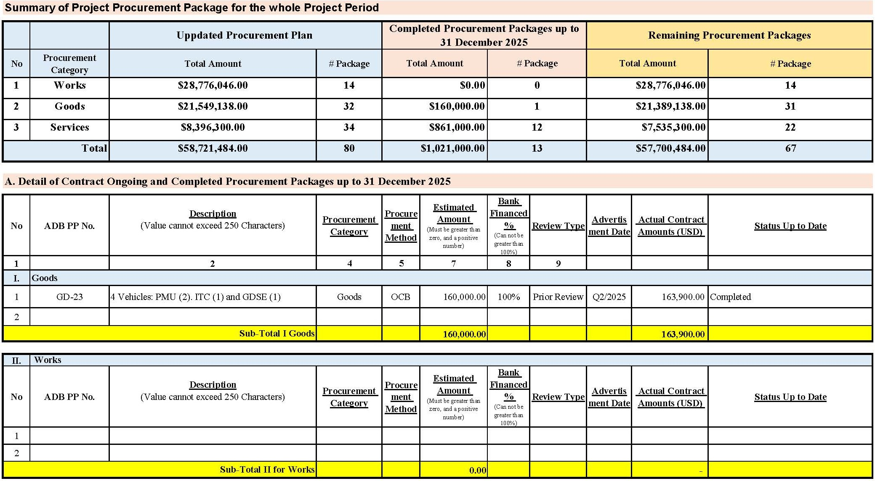
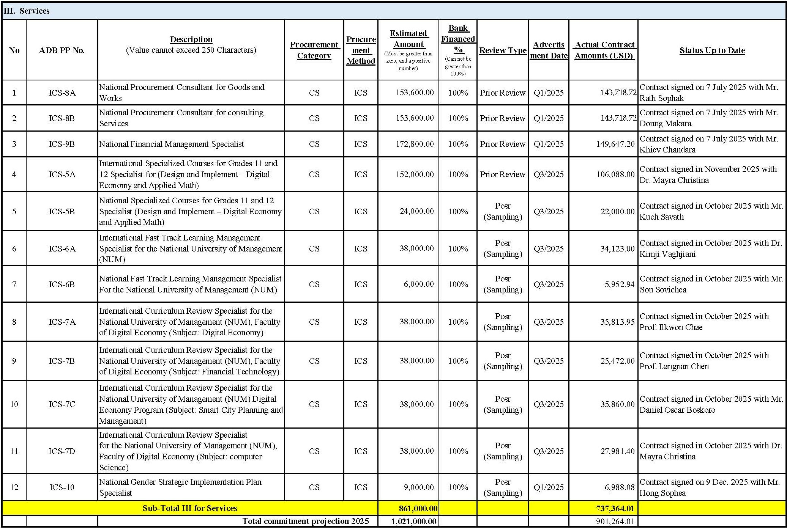
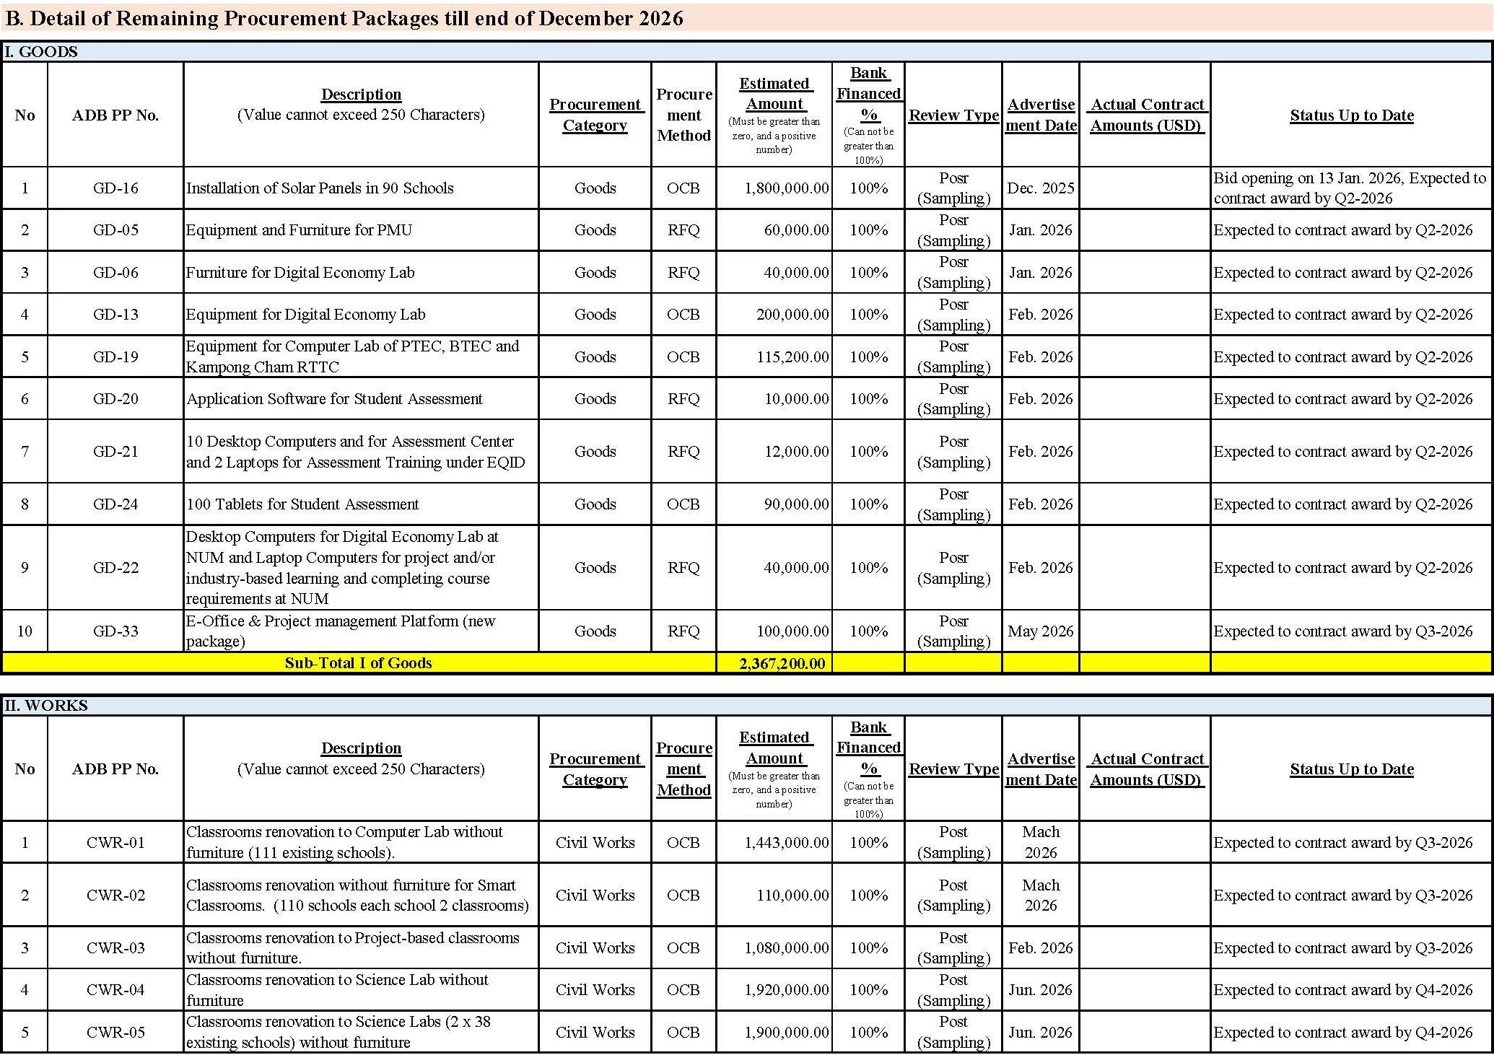
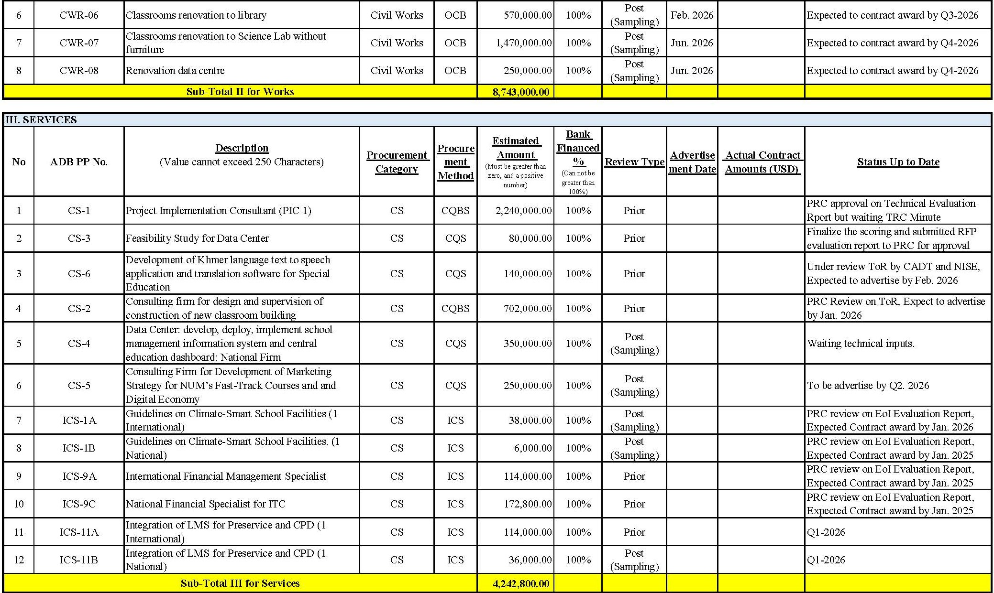

Appendix 5: Procurement Monitoring and Tracking Form (PMTF)

Appendix 5.1: Procurement Monitoring and Tracking Form – Goods
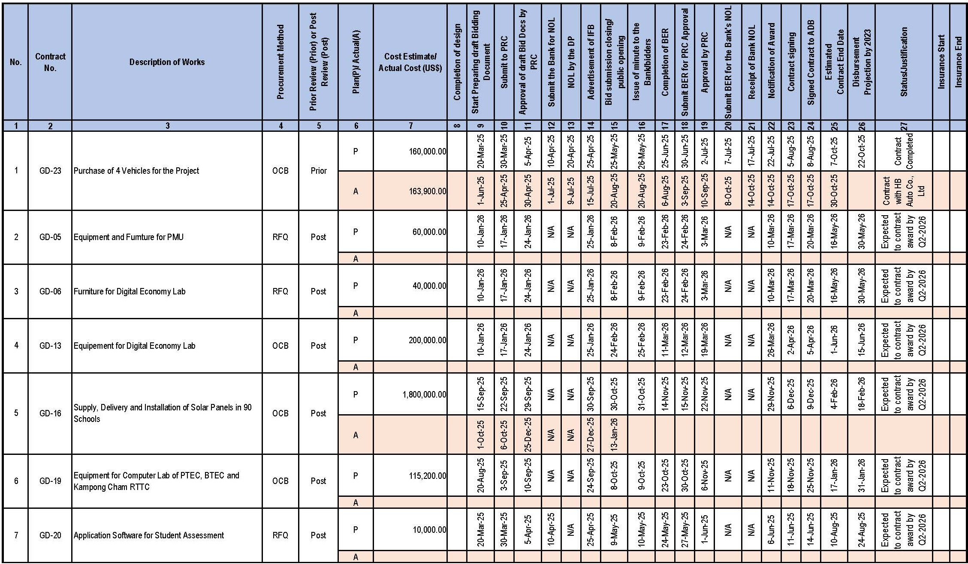
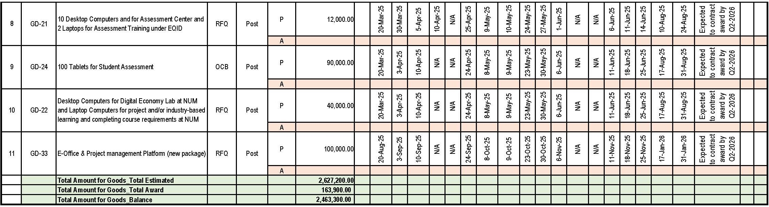

Appendix 5.2: Procurement Monitoring and Tracking Form – Works
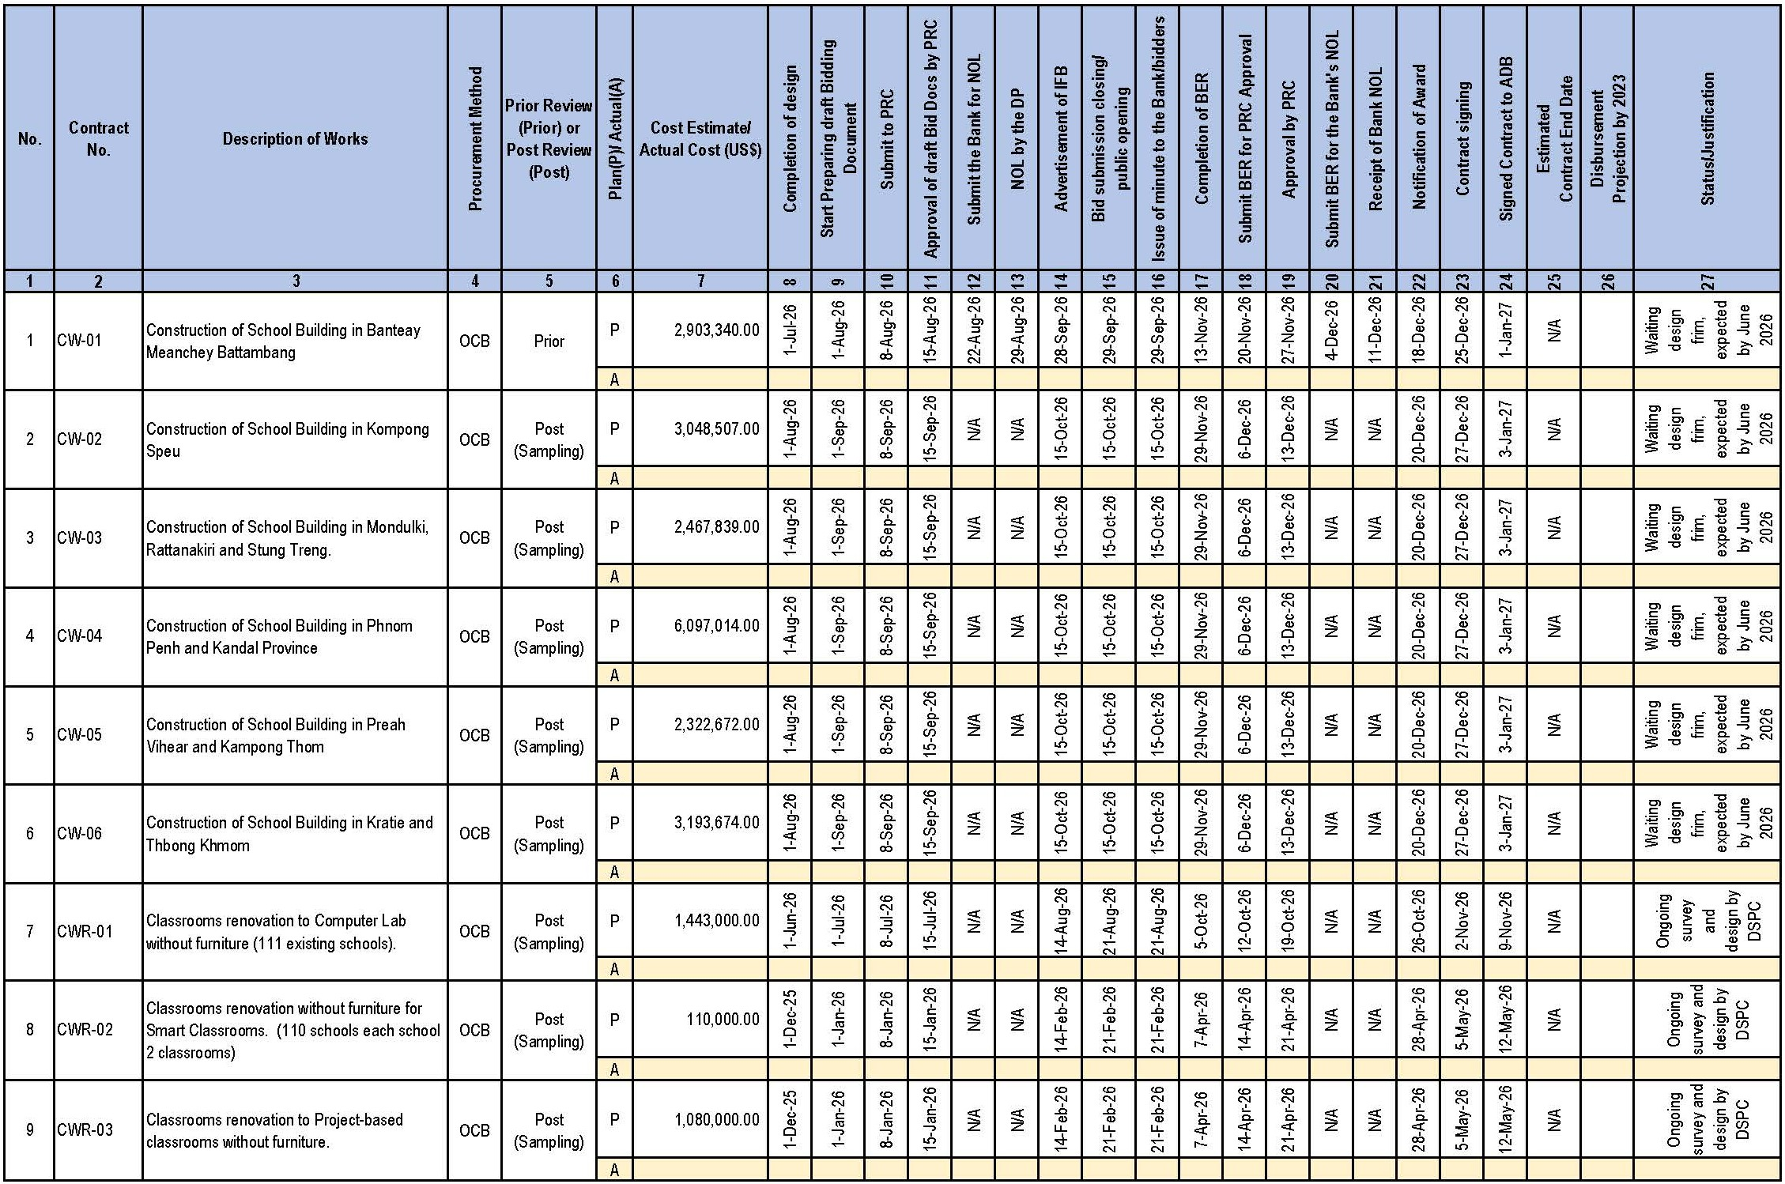
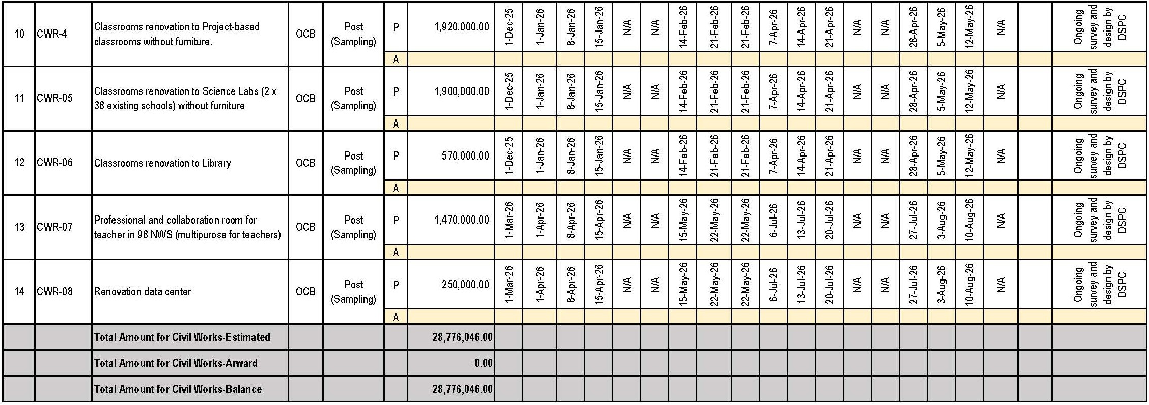

Appendix 5.3: Procurement Monitoring and Tracking Form - Consulting Firms

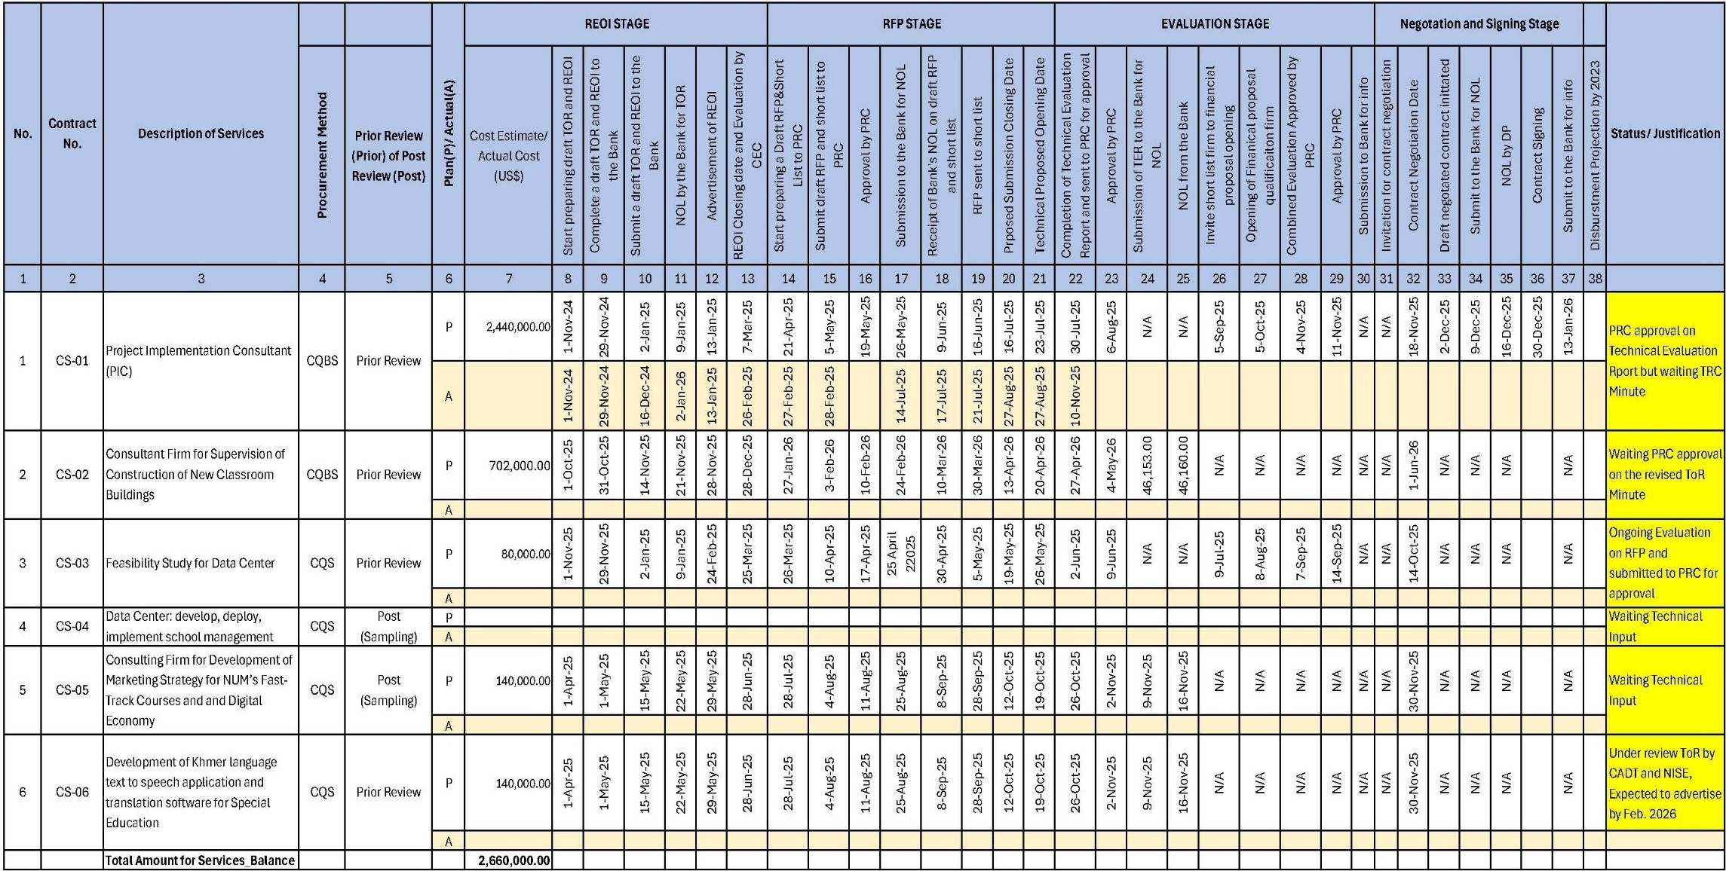

Appendix 5.4: Procurement Monitoring and Tracking Form - Individual Consulting
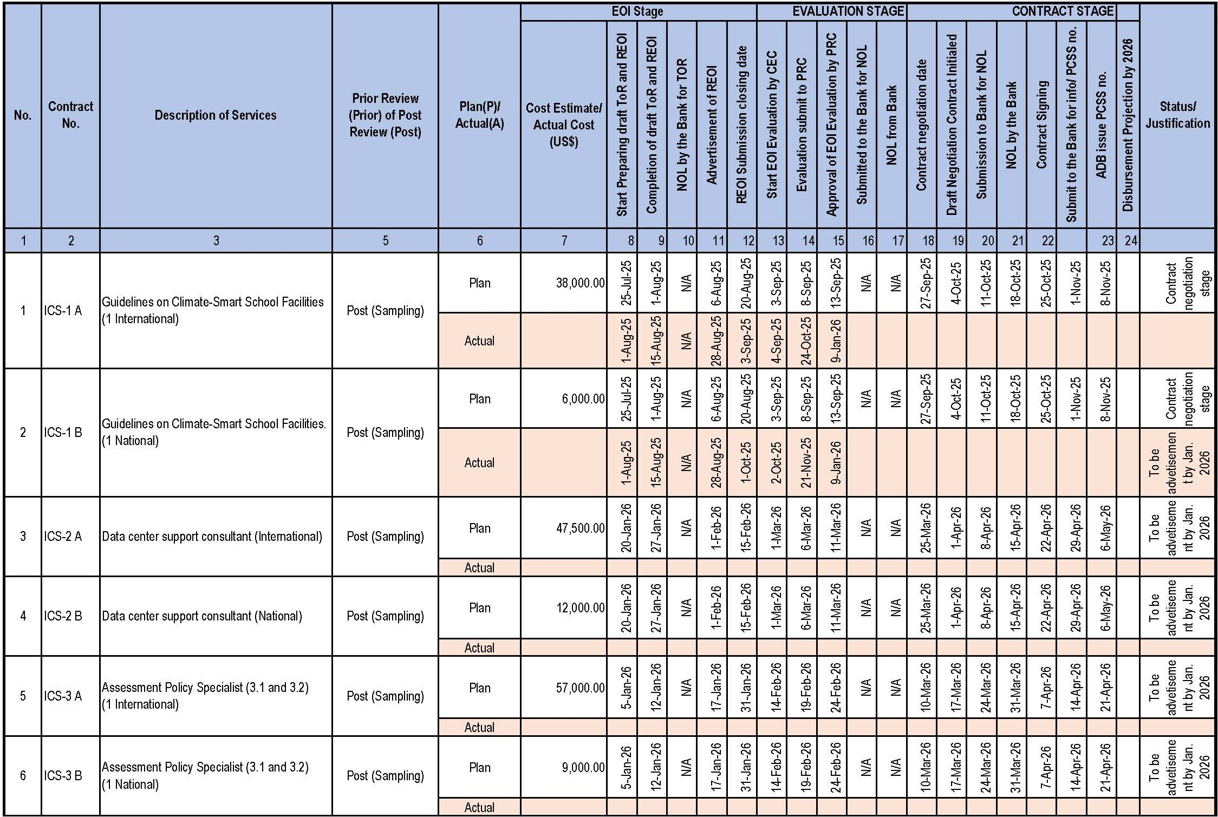

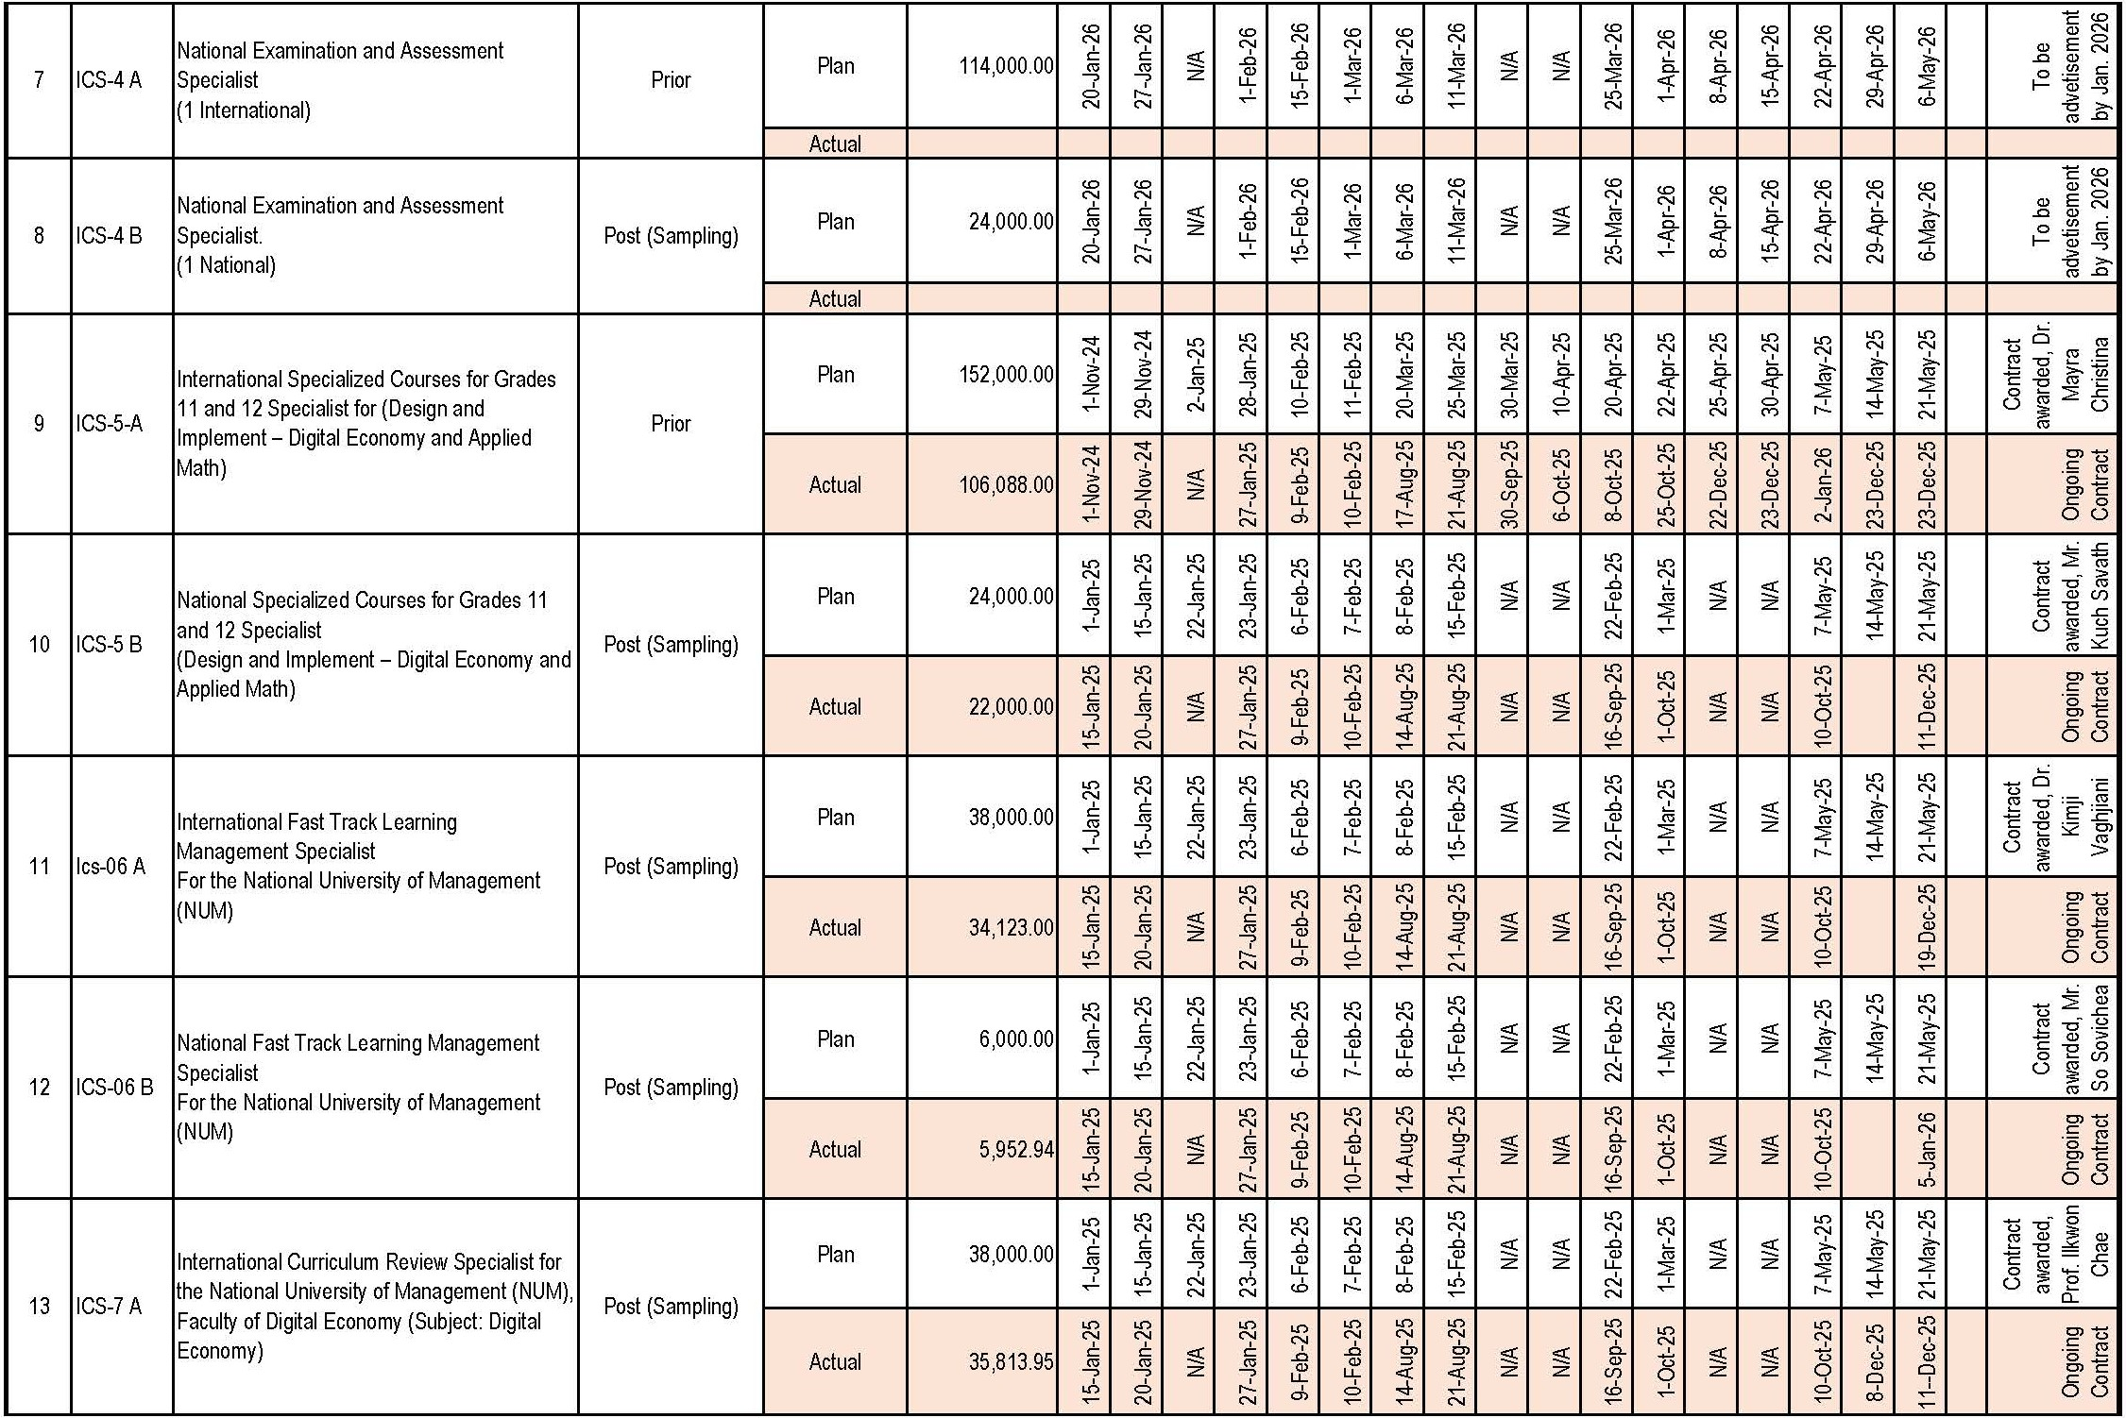
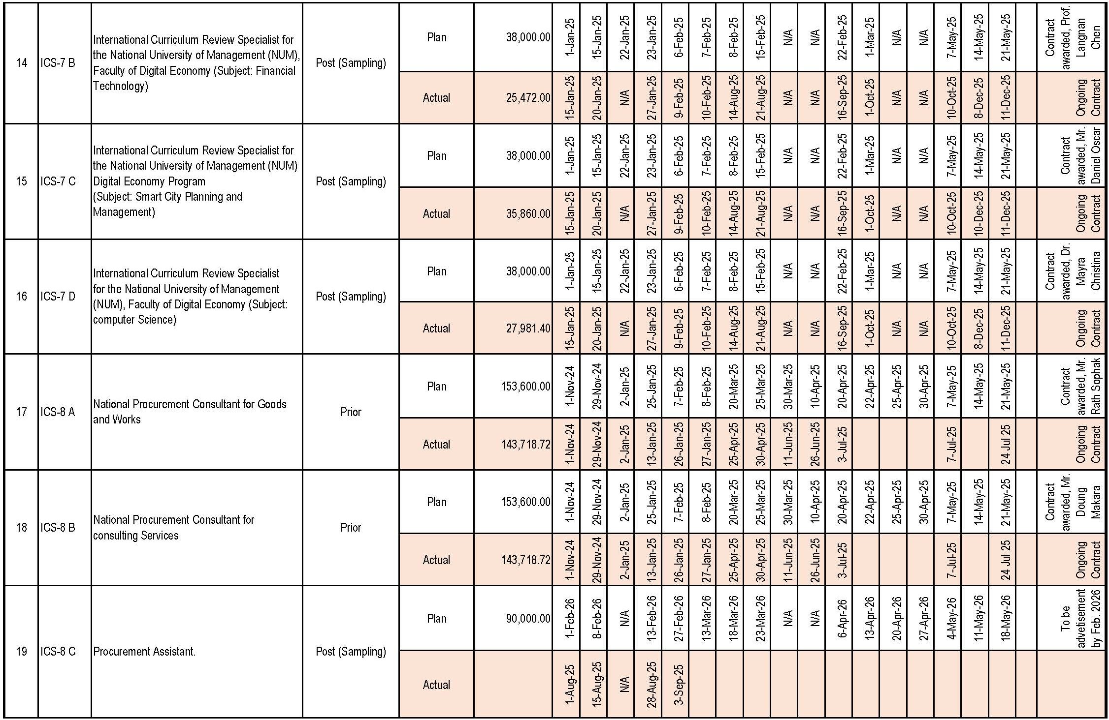
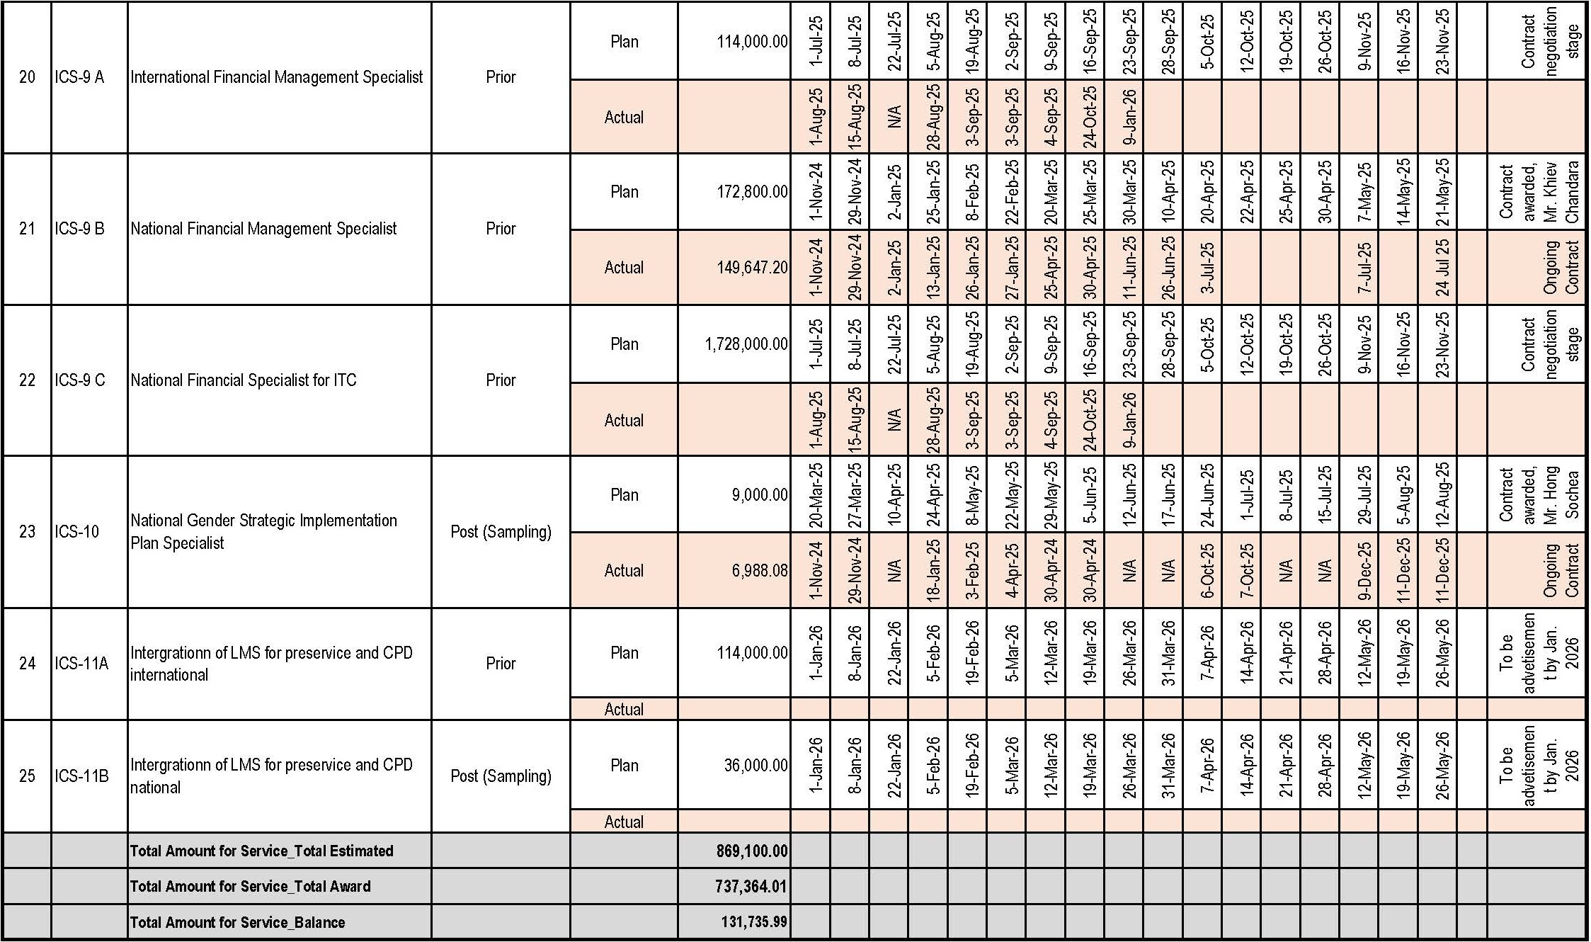

Appendix 6: Quarter/Annual Projection Table

Category Ref. | Description | Q1 (US$) | Q2 (US$) | Q3 (US$) | Q4 (US$) | Total (US$)
1 | Works | - | - | - | - | -
2 | Goods | - | - | - | 244,000 | 244,000
3 | Consulting Services | - | 9,600 | 281,000 | 324,400 | 615,000
4 | Capacity building | - | - | 40,745 | 41,666 | 82,411
5 | Recurrent Cost (ADB) | - | 11,430 | 170,067 | 163,992 | 345,489
5 | Recurrent Cost (RGC) | - | 29,700 | 29,700 | 29,700 | 89,100
Total |  | - | 50,730 | 521,512 | 803,758 | 1,376,000
Note: AWPB 2025: ADB’s Approval on 12 Jun 2025

Appendix 7: Loan Covenants Status

No. | Covenant | Reference in Loan Agreement | Status of Compliance
1 | In the carrying out of the Project and operation of the Project facilities, the Borrower shall perform, or cause to be performed, all obligations set forth in Schedule 4 to this Loan Agreement. | Article IV, Section 4.01 | Being complied.  The project has been implemented follows the PAM and other clause set in the Loan agreement
2 | (a) The Borrower shall cause the Project Executing Agency to  (i) maintain separate accounts and records for the Project;  (ii) prepare annual financial statements for the Project in accordance with financial reporting standards acceptable to ADB;  - have such financial statements audited annually by independent auditors whose qualifications, experience and terms of reference are acceptable to ADB, in accordance with auditing standards acceptable to ADB;  - as part of each such audit, have the auditors prepare a report, which includes the auditors’ opinion(s) on the financial statements and the use of the Loan proceeds, and a management letter (which sets out the deficiencies in the internal control of the Project that were identified in the course of the audit, if any); and  - furnish to ADB, no later than 6 months after the end of each related fiscal year, copies of such audited financial statements, audit report and management letter, all in the English language, and such other information concerning these documents and the audit thereof as ADB shall from time-to-time reasonably request.  - ADB shall disclose the annual audited financial statements for the Project and the opinion of the auditors on the financial statements within 14 days of the date of ADB’s confirmation of their acceptability by posting them on ADB’s website.  - The Borrower shall enable ADB, upon ADB’s request, to discuss the financial statements for the Project and the Borrower’s financial affairs where they relate to the Project with the auditors appointed pursuant to subsection (a)(iii) hereinabove, and shall authorize and require any representative of such auditors to participate in any such discussions requested by ADB. This is provided that such discussions shall be conducted only in the presence of an authorized officer of the Borrower, unless the Borrower shall otherwise agree. | Article IV, Section 4.02. | Being complied.  (a)  (i) The project’s financial and accounting records are being maintained using project specific chart of accounts in Sage 50 accounting software.  (ii) Project prepared financial statements in accordance with a cash basis of accounting of the Cash Basis of Cambodia Public Sector Accounting Standards (CPSAS).  (iii) Financial statements will be annually audited by the independent auditor.  (iv) Auditor will prepare a report that includes auditors’ opinion.  (v) Audit Project Financial Statement (APFS) will be submitted in a timely manner.  (b) Being complied with.  ADB will disclose the APFS on the ADB website including opinions of auditors on financial statements.  (c) Being complied with.  Up on ADB’s request, all the project related financial statements and/or auditors’ views will be discussed and/or addressed on time.
3 | The Borrower shall enable ADB’s representatives to inspect the Project, the Goods, Works and Services, and any relevant records and documents. | Article IV, Section 4.03. | We recognize the Borrower's obligation to facilitate inspections by ADB representatives.  While the project is still in its early stages and no inspections have yet occurred, we are prepared to arrange and support any future requests from ADB to inspect the Project, related Goods, Works, Services, and pertinent records and documents in accordanceance with the Loan Agreement.
4 | Implementation Arrangements  The Borrower shall ensure, and cause the Project Executing Agency to ensure, that the Project is implemented in accordance with the detailed arrangements set forth in the PAM. Any subsequent change to the PAM shall become effective only after approval of such change by the Borrower and ADB. In the event of any discrepancy between the PAM and this Loan Agreement, the provisions of this Loan Agreement shall prevail. | Schedule 4, para 1 | All project activities initiated so far are proceeding based on the detailed arrangements set forth in the currently approved PAM.  We will ensure that any future modifications to the PAM must undergo the formal approval process involving both the Borrower and ADB before taking effect. We will ensure this process is strictly followed if any changes become necessary as the project progresses.  Based on the recent ADB Support Review Mission in October 2026, we will revise the procument plan by including some procurment packages. We will submit the revised package for approval from ADB and the MoEF.
5 | Procurement  The Borrower shall ensure, or cause the Project Executing Agency to ensure, that:  - the procurement of Goods, Works and Services is carried out in accordance with the Procurement Policy, the Procurement Regulations and the Standard Operating Procedures;  - Goods, Works and Services shall be procured based on the detailed arrangements set forth in the Procurement Plan, including the procurement and selection methods, the type of bidding documents, and ADB’s review requirements. The Borrower may modify the detailed arrangements set forth in the Procurement Plan only with the prior agreement of ADB, and such modifications must be set out in updates to the Procurement Plan; and  - (i) all Goods and Works procured and Services obtained (including all computer hardware, software and systems, whether separately procured or incorporated within other goods and services procured) do not violate or infringe any industrial property or intellectual property right or claim of any third party; and (ii) all contracts for the procurement of Goods, Works and Services contain appropriate representations, warranties and, if appropriate, indemnities from the contractor, supplier, consultant or service provider with respect to the matters referred to in this subparagraph. | Schedule 4, para 2 | We will ensure the procurement of Goods, Works and Services that are compliant with stipulated procurement framework, including the ADB Procurement Policy, Regulations, and SOPs.  Procurement is proceeding based on the agreed Procurement Plan, with no unapproved deviations. If there is a need to modification of the procurement plan, we will undergo the formal approval process involving both the Borrower and ADB before taking effect.  Contractual provisions addressing intellectual property rights and associated warranties/indemnities are being incorporated as required.  We will maintain full compliance with all procurement requirements throughout the project implementation.
6 | Contract Award  The Borrower shall not, or shall cause the Project Executing Agency not to, award any Works contracts which involves environmental impacts until:  - the relevant environment authority of the Borrower has granted all the necessary domestic environmental clearances;  - the Borrower has obtained ADB’s clearance of the IEE based on the final design; and  - the Borrower has incorporated the relevant provisions from the EMP into the Works contract. | Schedule 4, para 3 | We have ensured that all mandatory conditions – necessary domestic environmental clearances, ADB IEE clearance based on final design, and EMP incorporation into the contract has been fully satisfied prior to the award of any such future contracts.  Furthermore, to ensure comprehensive environmental and social safeguard (ESS) management in line with project requirements, we conducted pre-construction site assessments to confirm no adverse ESS impacts prior to civil works commencement.  We established the project's Grievance Redress Committee (GRC) to manage the Grievance Redress Mechanism (GRM). We iniated the collection of relevant Indigenous Peoples (IP) data, if applicable to project schools.  We are now developing a project-specific Safeguard Manual to be finalized by Q1 2026.  We conducted regular Environmental and Social Safeguard reporting requirements.
7 | Environment  The Borrower shall ensure, or cause the Project Executing Agency to ensure, that the preparation, design, construction, implementation, operation and decommissioning of the Project and all Project facilities comply with (a) all applicable laws and regulations of the Borrower relating to environment, health and safety; (b) the Environmental Safeguards; and (c) all measures and requirements set forth in the IEE, the EMP, and any corrective or preventative actions set forth in the Environmental Safeguards Monitoring Report. | Schedule 4, para 4 | - Upto now the project is compliance with the national environmental, health, and safety laws/regulations, ADB's Environmental Safeguards, and all requirements within the project's IEE and EMP throughout all project phases.  We are prepared to implement all specific IEE/EMP measures as project implementation progresses. ent.  We established the project's Grievance Redress Committee (GRC) to manage the Grievance Redress Mechanism (GRM). We iniated the collection of relevant Indigenous Peoples (IP) data, if applicable to project schools.  We are now developing a project-specific Safeguard Manual to be finalized by Q1 2026.  We conducted regular Environmental and Social Safeguard reporting requirements.
8 | Involuntary Resettlement  The Borrower shall ensure, or cause the Project Executing Agency to ensure, that the Project does not have any involuntary resettlement impacts, all within the meaning of the SPS. In the event that the Project does have any such impact, the Borrower, through the Project Executing Agency, shall take all steps required to ensure that the Project complies with the applicable laws and regulations of the Borrower and with the SPS. | Schedule 4, para 5 | In line with its Category C classification for Involuntary Resettlement (no impacts anticipated) under ADB's SPS, Project SE4HC is designed to avoid such impacts. Accordingly, specific IR compliance actions are not required at this time. We will continue monitoring to ensure this remains the case.
9 | Indigenous Peoples  The Borrower shall ensure, or cause the Project Executing Agency to ensure, that the preparation, design, construction, implementation and operation of the Project and all Project facilities comply with (a) all applicable laws and regulations of the Borrower relating to indigenous peoples; (b) the Indigenous Peoples Safeguards; and (c) all measures and requirements set forth in the IPP, and any corrective or preventative actions set forth in the Social Safeguards Monitoring Report. | Schedule 4, para 6 | Project SE4HC adheres to Indigenous Peoples safeguard requirements (ADB SPS & national laws). While no IPP is currently required as project is classified as Category C for Involuntary Resettlement , we will initiate IP data collection for project schools (if applicable) to ensure continued compliance and as part of ongoing monitoring.
10 | Human and Financial Resources to Implement Safeguards Requirements  The Borrower shall make available, or cause the Project Executing Agency to make available, necessary budgetary and human resources to fully implement the EMP and the IPP. | Schedule 4, para 7 | Three competent staff from the Property and Construction department are nominated for this work. The budget under the PMU are also allocated for these matters.
11 | Safeguards – Related Provisions in Bidding Documents and Works Contracts  The Borrower shall ensure, or cause the Project Executing Agency to ensure, that all bidding documents and contracts for Works contain provisions that require contractors to:  - comply with the measures relevant to the contractor set forth in the IEE, the EMP, the IPP, and the DDR (to the extent they concern impacts on affected people during construction), and any corrective or preventative actions set forth in the Environmental Safeguards Monitoring Report and the Social Safeguards Monitoring Report;  - make available a budget for all such environmental and social measures;  - provide the Borrower with a written notice of any unanticipated environmental, resettlement or indigenous peoples risks or impacts that arise during construction, implementation or operation of the Project that were not considered in the IEE, the EMP, the IPP, and the DDR;  - adequately record the condition of roads, agricultural land and other infrastructure prior to starting to transport materials and construction; and  - reinstate pathways, other local infrastructure, and agricultural land to at least their pre-project condition upon the completion of construction. | Schedule 4, para 8 | We will ensure the compliance with the Loan Agreement regarding safeguard provisions in procurement. Standard bidding document templates are being reviewed and updated to systematically incorporate mandatory clauses requiring contractors to: comply with all relevant measures in the IEE, EMP, and any applicable IPP/DDR; allocate budget for these measures; report unanticipated safeguard risks; record pre-construction site conditions; and reinstate infrastructure and land post-construction. This ensures these requirements are included in all relevant Works contracts as part of our established procurement review and approval process.
12 | Safeguards Monitoring and Reporting  The Borrower shall, or cause the Project Executing Agency to, do the following:  - submit semiannual Social Safeguards Monitoring Reports and annual Environmental Safeguards Monitoring Reports to ADB and disclose relevant information from such reports to affected persons promptly upon submission;  - if any unanticipated environmental and/or social risks and impacts arise during construction, implementation or operation of the Project that were not considered in the IEE, the EMP, the IPP, and the DDR, promptly inform ADB of the occurrence of such risks or impacts, with detailed description of the event and proposed corrective action plan; and  - report any actual or potential breach of compliance with the measures and requirements set forth in the EMP, the IPP, or the DDR promptly after becoming aware of the breach. | Schedule 4, para 9 | We will fulfill all safeguards monitoring and reporting obligations as per the Loan Agreement. We updated the Environmental Safeguards Monitoring Reports based on the recent ADB support mission in October.  We will keep informing ADB of any unanticipated environmental/social risks or impacts, and reporting any compliance breaches concerning the EMP or applicable IPP/DDR as soon as we become aware of them.  As a pre action, we will set out these obligations and clear protocols in our project safeguard Manual.
13 | Prohibited List of Investments  The Borrower shall ensure that no proceeds of the Loan are used to finance any activity included in the list of prohibited investment activities provided in Appendix 5 of the SPS. | Schedule 4, para 10 | We confirm adherence to the Loan Agreement's requirement regarding the Prohibited List of Investments (SPS Appendix 5). Project activities and planned expenditures have been screened, and internal controls are in place to ensure that no proceeds of the Loan will be used to finance any prohibited activities. We will ensure this compliance throughout the project.
14 | Grievance Redress Mechanism  The Borrower shall ensure, or cause the Project Executing Agency to ensure, that  - an efficient project-specific grievance redress mechanism is in place and functional to assist the affected persons to resolve queries and complaints related to safeguards concerns, if any, in a timely manner;  - all complaints are registered, investigated and resolved in a manner consistent with the provisions of grievance redress mechanism;  - the complainants/aggrieved person are kept informed about status of their grievances and remedies available to them; an  (d) adequate staff are resources are available for supervising and monitoring the mechanism. | Schedule 4, para 11 | We confirm adherence to the Loan Agreement's requirement regarding the Prohibited List of Investments (SPS Appendix 5). Project activities and planned expenditures have been screened, and internal controls are in place to ensure that no proceeds of the Loan will be used to finance any prohibited activities. We will ensure this compliance throughout the project.
15 | Labor Standards, Health and Safety  The Borrower shall ensure, and shall cause the Project Executing Agency to ensure, that the core labor standards and the Borrower’s applicable laws and regulations are complied with during Project implementation. The Borrower shall cause the Project Executing Agency and the implementing agency to include specific provisions in the bidding documents and contracts financed by ADB under the Project requiring that the contractors, among other things:  (a) comply with the Borrower’s applicable labor law and regulations and incorporate applicable workplace occupational safety norms;  (b) do not use child labor;  (c) do not discriminate against workers in respect of employment and occupation;  (d) do not use forced labor;  (e) allow freedom of association and effectively recognize the right to collective bargaining; and  (f) disseminate, or engage appropriate service providers to disseminate, information on the risks of sexually transmitted diseases, including HIV/AIDS, to the employees of contractors engaged under the Project and to members of the local communities surrounding the Project area, particularly women. | Schedule 4, para 12 | Our standard bidding documents and contract templates incorporated mandatory provisions requiring contractors to adhere fully to all specified labor standards, occupational health and safety norms, and awareness dissemination requirements (including STD/HIV/AIDS) as stipulated in the Loan Agreement. This ensures these crucial requirements are embedded in all relevant contracts through our established procurement process.
16 | Labor Standards, Health and Safety  The Borrower shall, or shall cause the Project Executing Agency to, strictly monitor compliance with the requirements set forth in paragraph 12 above and provide ADB with regular reports. | Schedule 4, para 13 | Regular reports on compliance status will be submitted to ADB as stipulated in the Loan Agreement.
17 | Gender and Development  The Borrower shall ensure, or shall cause the Project Executing Agency to ensure, that  (a) the GAAP is implemented in accordance with its terms;  (b) the bidding documents and contracts include relevant provisions for contractors to comply with the measures set forth in the GAAP;  (c) adequate resources are allocated for implementation of the GAAP; and  (d) progress on implementation of the GAAP, including progress toward achieving key gender outcome and output targets, are regularly monitored and reported to ADB. | Schedule 4, para 14 | We will ensure the implementation of the Gender Action Plan (GAAP) per its terms and progress reports will be submitted to ADB in the due course.  In order to ensure this compliance, monitoring and reporting mechanisms are actively being established.  We are developing Gender Action Matrix as part of M&E framework. We are collaborating with designated gender focal persons in PIUs for data collection, ensuring PMU activities systematically incorporate gender aspects using the GAAP guidelines. We provided targeted Gender Training for these focal persons.  A national gender specialist was selected. He will work with project gender focal person to develop the MOEYS gender strategy action plan. We will make sure the GAAP of the project aligned with the MOEYS gender strategy.
18 | Counterpart Support  The Borrower shall ensure that adequate budgetary allocations of required counterpart funds are made and released in a timely manner to the Project Executing Agency in order to ensure the prompt and successful implementation of the Project. | Schedule 4, para 15 | The Ministry of Economy and Finance as the Borrower has complied with obligation under the Loan Agreement to provide adequate and timely counterpart funding to the Project Executing Agency
19 | Counterpart Support  In addition to the foregoing, the Borrower shall ensure that the Project Executing Agency and the implementing agency have sufficient funds to satisfy its liabilities arising from any Works, Goods and/or Services contract. | Schedule 4, para 16 | The Borrower [Ministry of Economy and Finance] assures ADB that, consistent with the Loan Agreement, mechanisms are in place to ensure the Project Executing Agency and implementing agency possess adequate funds to satisfy all contractual liabilities incurred under Project SE4HC. Up to now, we have the sufficient funds to implement the project.
20 | Operation and maintenance  The Borrower shall provide budgetary allocations to the Project Executing Agency to ensure that adequate funds are available to fund the incremental recurrent costs of operating and maintaining the Project and to sustain the Project facilities in sound, functional order after completion of the Project. Furthermore, the Borrower shall cause the Project Executing Agency to ensure that qualified and experienced staff are made available to maintain the Project facilities in good working condition after completion of the Project. | Schedule 4, para 17 | We acknowledge the requirement for post-completion operation and maintenance (O&M) funding and staffing as per the Loan Agreement. Project SE4HC's design inherently addresses this through a focus on sustainability, primarily by building the institutional capacity of Higher Education Institutions (HEIs) and Teacher Education Institutions (TEIs) to manage and deliver Continuing Professional Development (CPD) programs independently post-project.  This approach ensures that O&M responsibilities, including necessary funding (planned for integration into the regular operational budgets of HEIs, TEIs, and project schools) and qualified staffing (developed through the project's capacity building efforts), will be absorbed institutionally upon project completion.  Specific operational arrangements to formalize this integration will be further discussed and prepared during project implementation.
21 | Governance and Anticorruption  The Borrower, the Project Executing Agency, and the implementing agency shall comply with ADB’s Anticorruption Policy (1998, as amended from time to time) and acknowledge that ADB reserves the right to investigate directly, or through its agents, any alleged corrupt, fraudulent, collusive or coercive practice relating to the Project; and (b) cooperate with any such investigation and extend all necessary assistance for satisfactory completion of such investigation. | Schedule 4, para 18 | The Borrower, Project Executing Agency, and implementing agency affirm their strict adherence to ADB’s Anticorruption Policy (1998, as amended). We fully acknowledge ADB’s right to investigate any alleged corrupt, fraudulent, collusive, or coercive practices relating to the Project and unequivocally commit to cooperating fully with any such investigation, extending all necessary assistance for its satisfactory completion.
22 | Governance and Anticorruption  The Borrower, the Project Executing Agency, and the implementing agency shall ensure that the anticorruption provisions acceptable to ADB are included in all bidding documents and contracts, including provisions specifying the right of ADB to audit and examine the records and accounts of the executing and implementing agency and all contractors, suppliers, consultants, and other service providers as they relate to the Project. | Schedule 4, para 19 | We confirm that anticorruption provisions acceptable to ADB, specifically including ADB's right to audit and examine the relevant records and accounts of the executing/implementing agencies and all contractors/suppliers/consultants, are being systematically incorporated into all bidding documents and contracts for Project SE4HC as standard procedure.

Appendix 8: Quarterly Financial Report

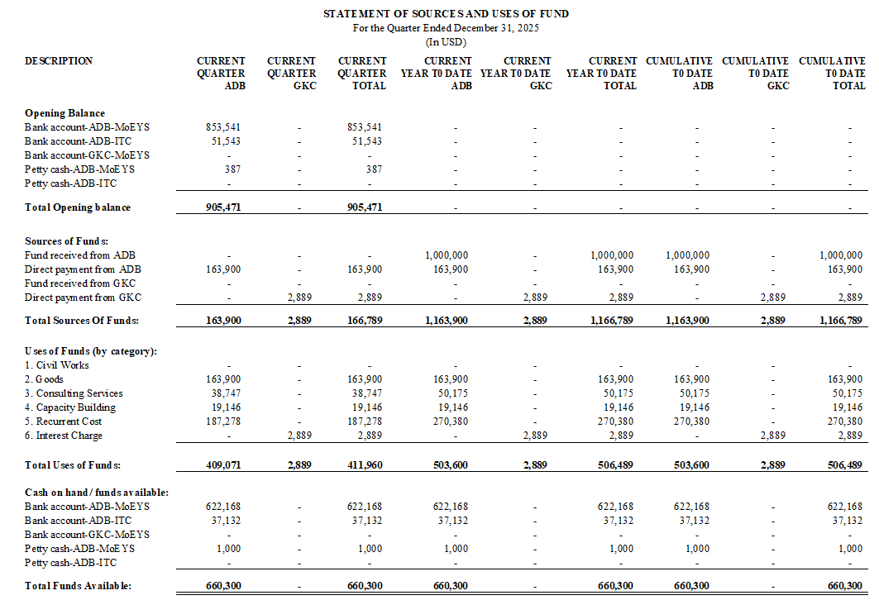
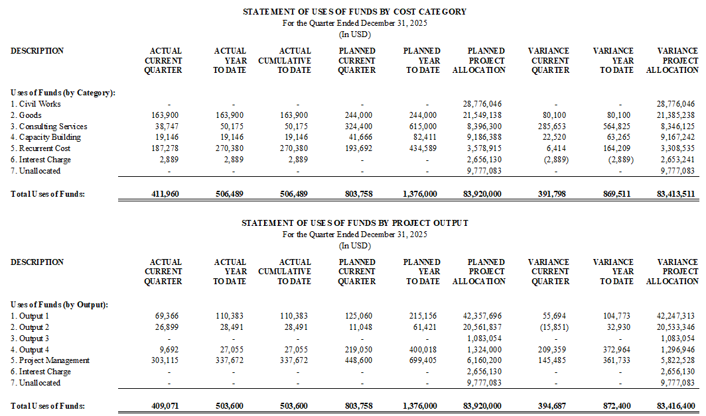

Appendix 9: Gender Action Plan (GAP) Reporting

I. OVERVIEW OF GAP IMPLEMENTATION PROGRESS

- Overall Progress: The project is classified as Gender Equality Objective (GEN) and includes 18 targets (3 targets at Outcome level: DMF a., DMF b., and DMF c. while 15 targets are at Outputs’ level) and 3 actions within the Gender Assessment and Action Plan (GAAP). The Design and Monitoring Framework (DMF) incorporates 13 DMF indicators including DMF a., DMF b., DMF c., DMF 1a, DMF 1c, DMF 1d, DMF 2a, DMF 2b, DMF 2d, DMF 3a, DMF 3b, DMF 4a and DMF 4b. As of 30 September 2025, eight targets are on track, while seven targets are not yet due and are awaiting progress from PIU1, TIU, DGSE, and NUM-DE. Additionally, two actions are on track, and one action has not yet been started. In June 2025, the PMU and ADB gender teams conducted an orientation on GAAP at MoEYS for all gender focal points from PMU, PIU, TIU, and NUM-DE. Furthermore, DoPo has submitted a proposal to revise Action 2 on GMSP development to implement the action plan, as UNICEF—through the Global Partnership for Education (GPE) and the Capacity Development Partnership Fund (CDPF)—will support the development of the Gender Mainstreaming Strategic Plan (GMSP) in the education sector.

- Overall Project Reach and Beneficiaries: Not yet progress.

- Key Challenges and Constraints of GAP Implementation: There has been limited involvement of gender focal points from PIU and TIU in the PIU and TIU’ activities.

II. GAP MONITORING TABLE
Gender Action Plan  (GAP Activities, Indicators, Targets, Timeframe and Responsibility) | Progress to Date (as of 30 September 2025)  [in this column include information on period of actual implementation, sex-disaggregated quantitative updates (e.g. number of participating women, women beneficiaries of services, etc.), and any relevant information.] | Highlights and Challenges  [Describe important successes and indicate any challenges in the achievement of targets of implementation of gender activities]
Outcome: Effectiveness and gender inclusivity of the USE system improved.
By 2030:  a. Increase in Grade 11 school-based  summative assessment score at project  schools by at least 5 percentage points for  girls and by 7 percentage points for boys  (Baseline to be set in SY2025/26) (DMF a.)  Target 1.  Responsibility: EMIS-DEMIS, EQID, DEA, PMU and CS-1, ICS-3A-3B  Timelines: 2025–2031 | Gender indicators have been incorporated in M&E system.  GAAP orientation conducted on 19 June 2025 at Administration Building Ponhea Hok, MoEYS with 14 people (5 female).  PMU has set target by year:  - Girl: increase to 1% (2027); to 3% (2028); to 4% (2029); and to 5% (2023).  - Boy: to 1% (2027); to 3% (2028); to 5% (2029) and to 7% (2023).  - Gender element has been integrated in the manual of environmental safeguard and gender. | On Track  Baseline assessment with schools will be done in 2026.
b. USE completion rate increases to at least 46.0% (50.0% for girls; 42.0% for boys) (SY2023/24 baseline: 38.4% overall, 42.5% for girls; 34.4% for boys) (DMF b.)  Target 2.  Responsibility: EMIS-DEMIS, EQID, DEA, PMU and CS-1  Timelines: 2025–2031 | Gender indicators have been incorporated in M&E system.  GAAP orientation conducted on 19 June 2025 at Administration Building Ponhea Hok, MoEYS with 14 people (5 female).  PMU has set annual target and will obtain the data from EMIS in January 2026.  Gender element has been integrated in the manual of environmental safeguard and gender. | On Track
c. Grade 12 student enrollment in science  stream increases by at least 5 percentage  points for girls and by 7 percentage points for boys (SY2022/23 baseline: 38.4% girls, 31.2% boys) (DMF c.)  Target 3.  Responsibility: EMIS-DEMIS, EQID, DEA, PMU and CS-1  Timelines: 2025–2031 | Gender indicators have been incorporated in M&E system.  GAAP orientation conducted on 19 June 2025 at Administration Building Ponhea Hok, MoEYS with 14 people (5 female).  PMU has set the annual target:  - Baseline 2024: Girl (38.4%) and Boy (31.2%)  - Target 2025: Girl (39.2%) and Boy (32.3%)  - Gender element has been integrated in the manual of environmental safeguard and gender. | On Track  Will follow up the data in 2025
Output 1: Access to quality upper secondary education expanded.
1a. 23 USSs upgraded with new classrooms with gender-responsive, socially inclusive, and climate-adaptive design features and WASH facilities (2024 baseline: 0) (DMF 1a.)  Target 4.  Responsibility: DSPC, DGSE, PMU, School Principals and CW-01-06, CS-1-2  Timelines: Year 2025-2027 | As of 31 December 2025:  - Completed assessment on classroom renovation in 72 of 245 schools.  - Completed TOR of international and national TA development of MOEYS guidelines for climate resilient school facilities.  - Gender team will work with TA to embed the gender responsive and socially inclusive design.  Integrated gender element in the environmental and safeguard and gender | On Track
1b. At least one public consultation conducted in each of 23 school sites with DSPC officers, school staff, teachers, and representatives of students, parents, and community leaders in focus school sites on the new classroom design features, and SEAH prevention and redress mechanism during construction (2024 baseline: 0)  Target 5.  Responsibility: DSPC, DGSE, PMU, School Principals and CS-1-2, ICS-1A  Timelines: Year 2025-2027 | - completed the assessment on site on the construction of 23 schools. | On Track
1c. At least 80% of all construction workers and managers report increased understanding on SEAH prevention and redress mechanism during civil work and 100% of construction workers sign the code of conduct (2024 baseline: 0)  Target 6.  Responsibility: DSPC, DGSE, PMU, School Principals and CS-1-2  Timelines: Year 2025-2027 | - Not yet start  - Gender team will embed the SEAH prevention and redress mechanism in the bidding documents.  - Gender team will ensure that all construction workers sign the code of conduct. | Not yet due
1d. Integrated Education Data Center  operationalized with school management  information system including socially inclusive and sex-disaggregated data (2024 baseline: 0) (DMF 1c.)  Action 1.  Responsibility: PMU, ITC and CS-1-2, ICS-2A-2B  Timelines: Year 2025-2027 | - Consulting service for feasibility study is under evaluation  - Gender team will work closely with consulting service to include the sex-disaggregated data as well as social inclusion. | On Track
1e. At least 90% of 259 USS target schools use SMIS to report sex-disaggregated data  biannually to track gender parity (2024 baseline: 0)  Target 7.  Responsibility: PMU, ITC and CS-1-2, ICS-3-4  Timelines: Year 2025-2027 | - Consulting service for feasibility study is under evaluation  - Gender team will work closely with consulting service to include the sex-disaggregated data as well as social inclusion.  - Gender team will monitor the implementation of 259 schools on SMIS. | On Track
1f. By 2026, MOEYS’ Gender Mainstreaming Strategic Plan for Education 2026–2030 developed and approved (2024 baseline: 0) (DMF 1d)  Action 2.  Responsibility: PMU, DGE and  DSPC, Directors and ICS-11  Timelines: Year 2025-2027 | - DoPo has proposed the justification for indicator change  - DoPo has developed the concept note for action plan development for MOEYS’s GMSP implementation.  - TA on board to discuss on the development of a comprehensive gender strategic implementation plan for the MoEYS’ s GMSP. | On Track  During the ADB inception mission, DMF 1d has been reported by PMU that UNICEF with Global Partnership for Education (GPE)/ the Capacity Development Partnership Fund (CDPF) grant funds will support to develop the Gender Mainstreaming Strategic Plan (GMSP) in Education Sector, therefore, the SE4HCC project will not implement this indicator. However, PMU requested to use the project budget under this indicator to develop the action plan for GMSP after it is approved expecting in December 2025. PMU will develop a concept note and will be submitted to ADB on the change by the completion of the Strategic Plan. Therefore, the DMF 1d will be also revised in the GAAP document.
1g. Two activities addressing gender norms  under the approved Gender Mainstreaming  Strategic Plan for Education, 2026–2030 action plan implemented (2024 baseline: 0)  Target 8.  Responsibility: PMU, DGE and  DSPC, Directors and CS-1, ICS-11  Timelines: Year 2025-2029 | - DoPo has proposed the justification for indicator change  - DoPo has developed the concept note for action plan development for MOEYS’s GMSP implementation.  - TA on board to discuss on the development of a comprehensive gender strategic implementation plan for the MoEYS’ s GMSP. | On Track
Output 2: Upper secondary education alignment with 21st-century skills improved.
2a. STEM project-based and applied learning CPD with gender-differentiated pedagogy implemented in at least 80.0% of target schools (2024 baseline: 0) (DMF 2a.)  Target 9.  Responsibility: PMU, DGE, BTEC, RTTC and NIE and CS-1  Timelines: Year 2026-2029 | - CPD on STEM Education: completed on-site survey  - CPD Content Development: completed including consultation to draft content and finalization. | On Track
2b. At least 880 teachers (of whom at least 25.0% are women) who participate in digital skills CPD report increased use of technology in teaching (2024 baseline: 0) (DMF 2b.)  Target 10.  Responsibility: PMU, DGE, BTEC, RTTC and NIE and CS-1  Timelines: Year 2026-2029 | - Not yet start (PIU1) | Not yet due
2c. At least 50% teachers from 259 USS who participated in project-based STEM CPD report the use of gender-differentiated pedagogy in projects undertaken with students (2024 baseline: 0)  Target 11.  Responsibility: PMU, DGE, BTEC, RTTC and NIE and CS-1  Timelines: Year 2026-2029 | - Not yet start (DGSE) | Not yet due
2d. One collaborative action research conducted by teachers from project schools address boys’ low performance and early-school-leaving (2024 baseline: 0)  Target 12.  Responsibility: PMU, DGE, BTEC, RTTC, NIE, ITC and CS-1  Timelines: Year 2026-2029 | - Not yet start | Not yet due
2e. CSTC fully equipped, staffed (with at least 30.0% women in management), and operational with climate smart, socially inclusive and gender-sensitive features (2024 baseline: 0) (DMF 2d.)  Target 13.  Responsibility: PMU, DGE, BTEC, RTTC, NIE, ITC and CS-1, ICS-7  Timelines: Year 2026-2029 | - Not yet start (ITC) | Not yet due
2f. 540 USE teachers (20% women) who  attended CPD report increased competency in English language pedagogy (2024 baseline: 0)  Target 14.  Responsibility: PMU, DGE, BTEC, RTTC, NIE, ITC and CS-1  Timelines: Year 2026-2029 | - Not yet start | Not yet due
2g. 250 science and mathematics subject team leads (25% women) from USSs, who have successfully completed the CPD program, receive scholarships to pursue local master’s degree programs in science and math pedagogy (2024 baseline: 0)  Target 15.  Responsibility: PMU, DGE, BTEC, RTTC, NIE, ITC and CS-1  Timelines: Year 2026-2029 | - Not yet start | Not yet due
Output 3: Quality of upper secondary education learning assessment system improved.
3a. 650 teachers (at least 25% women) who attend CPD report improved use of classroom- based assessment for teaching (2024 baseline: 0) (DMF 3a.)  Target 16.  Responsibility: PMU, DGE, NIE and EQID and CS-1, ICS-3A-3B  Timelines: Year 2027-2029 | - Not yet start (PIU1) | Not yet due
3b. Revised national examination strategy, based on gender-sensitive analysis, approved (2024 baseline: 0) (DMF 3b.)  Action 3.  Responsibility: PMU, DGE, NIE and EQID and CS-1, ICS-3A-3B  Timelines: Year 2027-2029 | - Not yet start (DEA, EQID) | Not yet due
Output 4: Post-secondary education pathways strengthened.
4a. Fast-track program (including environmental science modules) piloted in 25 schools, with at least 50% boys registered in the specialized courses (2024 baseline: 0) (DMF 4a.)  Target 17.  Responsibility: MOEYS, DGSE, NUM-DE and CS-1, ICS-5A-5B  Timelines: Year 2027-2029 | - Digital Economy and Applied Mathematics Courses have been produced.  - Successfully selected 25 USS schools for pilot fast-track program implementation in NUM-DE.  - Completed site visits to the target USS schools to assess the fast-track implementation  - Gender team will monitor the boy’s registration in the specialized courses. | On Track
4b. 120 students (at least 50% girls) enrolled in NUM-DE through the pilot fast-track program (2024 baseline: 0) (DMF 4b.)  Target 18.  Responsibility: MOEYS, DGSE, NUM-DE and CS-1, CS-6A-6B  Timelines: Year 2027-2031 | - Not yet start  - Gender team will monitor the boy’s registration in the specialized courses. | Not yet due

Appendix 10: Asset and inventory register 2025

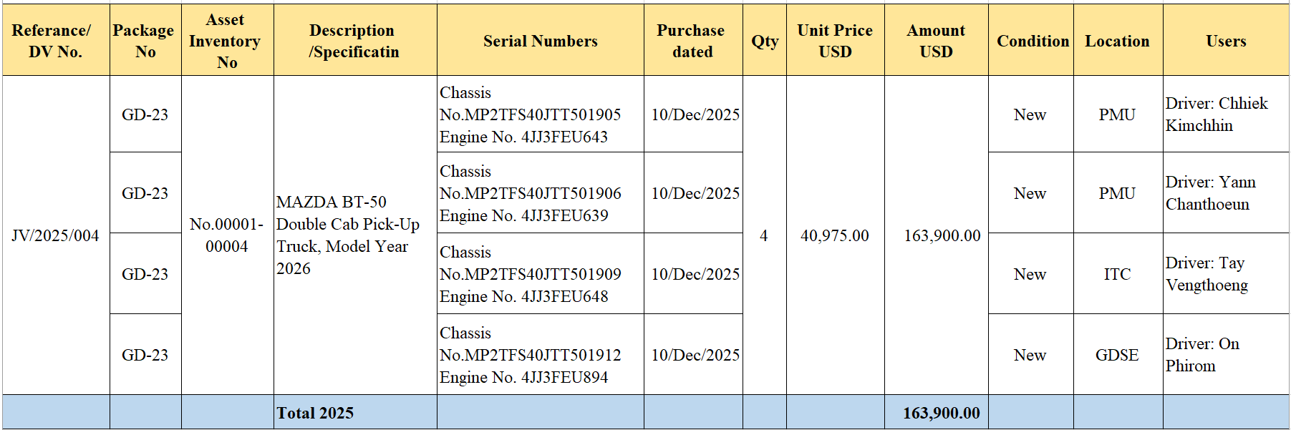

The baseline will be set after the development and administration of improved school-based summative assessment. The targets will be reassessed at midterm review. The past Grade 11 national assessment results indicate that girls consistently outperform boys, therefore a higher target is set for boys to narrow the gender gap.
Gender-responsive design features include safe, accessible and inclusive environment by addressing safety risks around harassment, sexual assault, and violence often faced by girls, LGBTQI, and other vulnerable students. This includes sex- segregated toilet facilities which are safe, private and with running water, to ensure dignified menstrual hygiene management.
Gender-sensitive features refer to exhibits that (i) depict women’s contribution and roles in STEM globally, within the Association of Southeast Asian Nations and locally; (ii) provide visuals, topics, and aesthetics related to women; and (iii) are accessible for women and girls with disabilities. Gender guidelines and checklist can be adapted from Exhibit Design for Girls’ Engagement (EDGE) and ASTC’s Gender Representation Toolkit.

